

SCHOOL *of* BUSINESS AND TECHNOLOGY

Department of Engineering and Aviation Sciences

Design of a Smart American Sign Language Translator

**Josheb Dayrit**

Advisor: Dr. Zhang

Spring 2020

**Table of Contents**

Abstract 1

1. Introduction 3

**1.1** Objective 6

**1.2** Design Requirements 6

**1.3** Design Constraints 6

**1.4** Design Method 7

2. Project Description 9

**2.1** System Description 9

**2.2** System Diagram 9

3. Implementation Plan 10

**3.1** Tasks 10

**3.2** Timeline/Milestones/Delivery Plan 11

4. Implementation 12

**4.1** Implementation of Task 1 12

4.1.1. Implementation of Subtasks 1 and 2 12

4.1.2. Implementation of Subtask 3 19

**4.2** Implementation of Task 2 21

4.2.1. Implementation of Subtask 1 21

4.2.2. Implementation of Subtask 2 26

4.2.3. Implementation of Subtask 3 30

**4.3** Implementation of Task 3 31

4.3.1. Implementation of Subtasks 1 and 2 31

4.3.2. Implementation of Subtask 3 37

**4.4** Implementation of Task 4 51

4.4.1. Implementation Flowchart 51

4.4.2. Implementation Overview 52

**4.5** Implementation of Task 5 52

4.5.1. Implementation Flowchart 52

4.5.2. Implementation Overview 54

**4.6** Implementation of Task 6 54

4.6.1. Preliminary Considerations 55

4.6.2. GUI Design 55

4.6.3. Refining GUI 56

4.6.4. Programming the GUI 57

4.6.5. Testing the GUI in Real-Time 59

5. Conclusion 65

Acknowledgments 67

Appendix 68

A. Device Specifications 68

1. Device Specifications of Myo Armband 68

B. Source Code 69

1. Source Code for GUI 69

2. Source Code for Data Logger 86

3. Source Code for Speech-to-Text Module 93

4. Source Code for Text-to-Speech Module 94

5. Source Code for Interfacing with Neural Network 96

References 99

**List of Figures**

Fig 1. Rates of employment in 2014 (deaf vs non-deaf) [3] 3

Fig 2. The system diagram of Sign AI 9

Fig 3. EMG sensor modules in Myo armband [5] 13

Fig 4. Invensense MPU-9150 on the back of the motherboard [5] 13

Fig 5. Processor for Myo armband [5] 13

Fig 6. Setup for each sensor [6] 14

Fig 7. Accuracies of 2 models for each EMG device [6] 15

Fig 8. The data-logging algorithm 18

Fig 9. The data-formatting algorithm 20

Fig 10. ASL for “try” (final hand position) [8] 22

Fig 11. ASL for “rock” (final hand position) [8] 22

Fig 12. A simple RNN layer [11] 27

Fig 13. The cell state, highlighted in a diagram of an LSTM layer [12] 27

Fig 14. The “gates,” denoted by a lowercase sigma (σ) [12] 28

Fig 15. “Forget” gate, highlighted in a diagram of an LSTM layer [12] 29

Fig 16. “Update” gate, highlighted in a diagram of an LSTM layer [12] 29

Fig 17. “Output” gate, highlighted in a diagram of an LSTM layer [12] 30

Fig 18. Initializing a neural network through Keras 32

Fig 19. Adding a layer to a sequential model 33

Fig 20. Fully defining the neural network in the codespace 33

Fig 21. Packaging the finished neural network using the “compile” function 35

Fig 22. Initiating the training process in Keras 36

Fig 23. Comparison of a layer with and without dropout [15] 41

Fig 25. Backpropagation at work [17] 42

Fig 26. Comparing the accuracy of the neural network in 2 datasets (train and test) 46

Fig 27. Comparing the accuracy of the neural network in 2 datasets (train and test) 47

Fig 28. Flowchart of Gesture-to-Speech Algorithm 52

Fig 29. Flowchart of Speech-to-Text Algorithm 53

Fig 30. Preliminary design of the GUI 56

Fig 31. Revised GUI design 57

Fig 32. EMG readings of all samples of the “marriage” gesture (train) 62

Fig 33. A random EMG sample of the “marriage” gesture (train; right prediction) 63

Fig 34. “Marriage” performed with increased force (wrong prediction) 63

Fig 35. “Marriage” performed after exercise (wrong prediction) 64

**List of Tables**

Table 1. Predicted Timeline for Tasks 11

Table 2. Parameters of Finalized Neural Network 45

Table 3. Evaluating Performance via Measuring Number of Translation Attempts 60

Table 4. Evaluating the Accuracy of Gesture Detection in First Attempt 60

Table 5. Myo Armband Specifications [6] 68

Abstract

Physical disabilities can prevent people from immersing themselves in everything society has to offer. Deafness, in particular, has a significant impact on a person’s life in that it prevents one from communicating through speech. Studies show that deaf persons are less likely to make use of medical services and are more prone to psychological disorders, disorders likely stemming from the difficulty of forming meaningful connections with hearing counterparts. There have also been recorded instances of discrimination in employment due to physical disabilities, including deafness. In the case of deafness, communication with others is the overarching issue, bringing with it a deluge of inevitable side-effects.

To talk specifics, the following project – named Sign AI – seeks to develop a word-by-word ASL (American Sign Language) translation tool. Keeping software compatibility in mind, the tool will be hosted on a Windows-based computer. A deep learning model will be trained to recognize ASL through pre-processed EMG (electromyography) data and orientation data in the form of quaternions, all acquired by the Myo armband by Thalmic Labs. The translation tool will take the form of a Windows-based GUI program (created through the Tkinter GUI toolkit) with which users can interact for various purposes. When used in conjunction with the neural network, the GUI presents users with the missing part: control over when a translation is performed. The end product, tailor-made for the deaf demographic, is expected to offer a “sign” and “listen” functionality, whereby deaf users can sign and listen using elements in the GUI. These functionalities (dubbed “communication features” in the paper) come in the form of speech-to-text and text-to-speech APIs, which can be activated at will through buttons. Translation accuracy hinges on the deep learning model and its ability to differentiate between different types of EMG data. For Sign AI, ease of use is of utmost importance. Ease of use is incorporated in the design process by making the GUI easy-to-navigate and require as little heavy-lifting from the user as possible.

1. Introduction

In a society that communicates through speech, it will be difficult for deaf persons to interact effectively with their non-deaf peers. According to the Gallaudet Research Institute, in the year 2006, “nearly 10,000,000 persons (Americans) are hard of hearing and close to 1,000,000 are functionally deaf” [1]. This is also corroborated by more recent 2012 statistics from the Centers for Disease Control and Prevention (CDC), which state that “approximately 15% of American adults (37.5 million) aged 18 and over report some trouble hearing” [2]. While the CDC clarifies that “the overall annual prevalence of hearing loss (has) dropped slightly” with time (from 16% in 1999 to 14% in 2012), additional findings from the National Deaf Center on Post-Secondary Outcomes reveal an alarming truth about deafness: “In 2014, only 48% of deaf people were employed, compared to 72% of hearing people” [3].

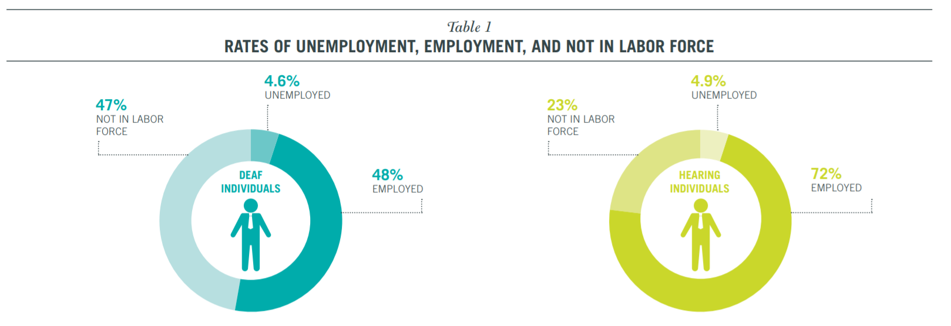

1. Rates of employment in 2014 (deaf vs non-deaf) [3]

Unfortunately, disparities in opportunities and (to some extent) outcomes are due in large part to physical disabilities, as shown by the countless statistics on deaf people. Since deaf people are not capable of speech, they choose to communicate through gesture-based languages, such as American Sign Language (ASL). Because of this, however, prospects for work are limited for deaf people. The harsh reality is that many employers are unwilling to hire deaf employees. While the ADA (American Discrimination Act) outlaws discriminatory practices based on race, gender, or disability, it does not prevent them entirely. In an American study which closely scrutinized successful discrimination lawsuits made against companies, the EEOC (Equal Employment Opportunity Commission) concluded that “young people who are deaf or hard of hearing may be advised to anticipate some resistance from employers” [4].

As outrageous as it sounds, even if a deaf candidate applies for a position while possessing qualifications that meet or exceed a company’s standards, the factor that determines their employment is whether or not they require excessive accommodation. From a corporate perspective, hiring employees who will only place an undue burden on a company and its resources is generally not worth the cost. This idea also aligns with the EEOC’s secondary conclusion, which states that disabled applicants who “articulate well their qualifications” and provide long-term workarounds or solutions to their disabilities are “more likely than others to find success in the world of work.”

One solution that Sign AI brings to the table is the function of a basic, real-time, AI-based ASL translation tool. The inability to speak properly is one disadvantage of deaf persons that either prevents them from fully pursuing specific career paths or leads them to be unjustifiably discriminated against in their search for employment. This inability stems from the fact that speech is a product of both the ears and the mouth; the mouth produces the sounds, while the ears regulate them. Without coordination from both the mouth and ears, it becomes increasingly difficult to produce intelligible speech. Many non-deaf employers simply do not have the time to learn sign language for their deaf applicants. In the hiring process, most are likely to turn their attention to the non-deaf candidates, even if the deaf candidates have the necessary qualifications. Such discrimination is, by all accounts, unfair. However, there is some wisdom to be found in it, even if morally questionable. All businesses are utilitarian in that their goal is to maximize productivity while minimizing expenditures of any sort (human, financial, etc.). If a prospective employee demands more from a company than their fellow competitors, that company will likely settle for those competitors in hopes of making things easier on themselves. While Sign AI cannot shift this mindset, it can address the most prominent disadvantage encumbering deaf persons when competing with their non-deaf peers.

As stated before, while deaf people face many barriers of entry regarding employment, communication is by far the most pressing issue. In the workplace, collaboration among employees is important. Typically, company projects are completed not by a single person, but by teams of people making collective contributions. A pre-requisite to effective collaboration is effective communication, especially in the nascent stages of a project, during which first impressions are gathered, and ideas are put forth for evaluation by others. For deaf persons, communication frequently comes in the form of sign language. Deaf persons have a hard time expressing their ideas to non-deaf persons because sign language is fundamentally different from spoken language. To bridge the gap between sign language and spoken language, a linguistic interface is needed between the two languages to translate one to the other. Sign AI strives to fulfill this role through a trained AI, a text-to-speech feature that will speak out the meaning of various ASL gestures, and a speech-to-text feature that will convert spoken word back to text.

At present, similar ASL translation apps can be found in the market. However, a common limitation of many of these apps is that the translation only flows in one direction: the user can convert plain text into ASL performed by an avatar but not the other way around. One famous ASL translation app is “Hand Talk,” an app developed by the company Hand Talk Servicos. On the other hand, there are other apps that are currently not revealed to the public that allows for two-way communication. In particular, the MotionSavvy app was first introduced to the public in 2014 to meet the need. Like Sign AI, MotionSavvy uses AI for gesture recognition. However, instead of relying on the sensors to acquire gesture data, the app relies on image data of the hand that is decomposed into a minimalistic 3D model. Although the developers of MotionSavvy have unveiled a prototype to the general populace, the app is still not made accessible to anyone and is assumed to still be in development. Therefore, the specifics behind how it performs gesture recognition are not yet known.

## Objective

The objective of Sign AI is to design an ASL translator that creates a user-friendly experience by automating the translation process, which is performed gesture-by-gesture. Everything is done in the backend and little input is required from the user.

## Design Requirements

1. The final product is a gesture-based translator, providing translation for each gesture performed.
2. The final product can translate a total of 100 gestures.
3. The final product can differentiate between gestures with a minimum accuracy of 70 percent.
4. The final product will have gesture-to-speech and speech-to-text capabilities.
5. The final product will have an LCD to display speech-to-text outputs.

## Design Constraints

Although design constraints are few due to the “hands-off” nature of an AI project, undoubtedly, they do exist. One constraint lies in the ASL language itself, while others in hardware.

1. Some gestures are not arm-based or hand-based, which means that they cannot be reliably measured by certain sensors (i.e. EMG sensors).
2. If the neural network will be hosted locally, it must run on a device that possesses sufficient storage as well as processing power.
3. There are no pre-made datasets that can be used to train my neural network.
4. Wireless internet connection will be necessary to access text-to-speech and speech-to-text APIs.

## Design Method

The reliability of a neural network depends on 2 important factors: its architecture and the training data. If a neural network is underperforming, the reason will be related to one or both of the aforementioned factors. In the case of Sign AI, the training data originates from the Myo armband, which is a glorified sensing device. The Myo armband takes EMG readings from 8 different sensor modules and transmits to the host computer via Bluetooth. The sensor modules are also equipped with inertial measurement units, which the Myo armband accounts for when calculating quaternions. The Myo armband outputs EMG readings for gauging muscle activation and quaternions for representing orientation in 3D space.

Naturally, the start of any deep learning project involves determining a means of acquiring reliable data. While the meaning of “reliable data” is different from project to project, its function remains the same for every project: to capture qualities of *something*. The job of data is to capture desired qualities while the job of the neural network is to make sense of them. Data collection is expected to be a major bottleneck in the development of Sign AI, as it is a time-consuming endeavor. The task of collecting data and the task of training the neural network cannot be pipelined because the neural network takes in the collected data as an input. Once data is acquired, one must then design a neural network capable of processing collected data. Architectures for neural networks are plenty, and some even specialize in solving niche problems. For example, there exists the recurrent neural network (or RNN, for short), which is frequently used for pattern recognition in text and speech. In solving image-based problems, the convolutional neural network was developed to fulfill the need. The design of the neural network should be congruent with the type(s) of data it will be handling.

In the design of the GUI, several things have to be kept in mind, particularly the layout of the GUI and the functions that it will encompass and fulfill. Many aspects of GUI are interconnected in that the form and function of a GUI are not mutually exclusive. How will users control the GUI? What visual elements will aid the user in figuring out how to use the GUI? Is the GUI too cluttered that the user does not know how to navigate it? When a GUI is first designed, its intended purpose should be the priority. Every design decision should revolve around satisfying its main purpose. To this end, the process of making the GUI for Sign AI has been broken down into three parts: the overall layout of the GUI, the programming of its functions, and the addition of other visual items that can help facilitate the GUI’s job (e.g. the implementation of a list box that keeps track of all gestures performance).

1. Project Description

## System Description

Sign AI has 3 main parts: the neural network, the Myo armband, and the software and hardware for the communication features. The neural network is the crux of the system, as it is, for all intents and purposes, the translator itself. The neural network forms a unit and works in tandem with the Myo armband and other APIs, where Myo is responsible for data acquisition while the neural network data classification and the APIs for providing speech-to-text and text-to-speech capabilities. As stated before, Sign AI targets the needs of deaf persons. Therefore, Sign AI will not only translate gestures but also establish a method for allowing deaf users to understand spoken words. This is done through interfacing with external APIs such as Google’s Speech-to-Text and Text-to-Speech APIs.

## System Diagram

Figure 2 illustrates the system in its entirety (as described in the system description), as well as the important connections in the system that show how data is passed.

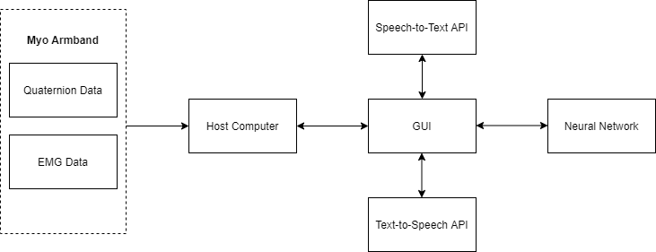

1. The system diagram of Sign AI
2. Implementation Plan

The implementation plan will discuss the tasks laid out for the project. The tasks are described below.

## Tasks

Task 1: Data Acquisition and Data Processing

Subtask 1.1: Interface computing devices and sensing devices.

Subtask 1.2: Write code to automatically document all sensor outputs.

Subtask 1.3: Write code to automatically format data for use in a neural network.

Task 2: Neural Network Design

Subtask 2.1: Propose a data visualization method for sensor data.

Subtask 2.2: Determine a suitable neural network architecture for the project.

Subtask 2.3: Verify the feasibility of the proposed data visualization method and neural network architecture.

Task 3: Neural Network Implementation

Subtask 3.1: Create a TensorFlow model based on the results of Task 1.

Subtask 3.2: Train the TensorFlow model using acquired sensor data.

Subtask 3.3: Refine the TensorFlow model to optimize performance.

Task 4: Design of Gesture-to-Speech Feature

Task 5: Design of Speech-to-Text Feature

Task 6: Design of Graphical User Interface (GUI)

## Timeline/Milestones/Delivery Plan

Table 1 lists the weeks during which certain tasks will be performed. Of course, things are always subject to change to account for unexpected circumstances. However, this is the expected timeline.

1. **Predicted Timeline for Tasks**

|  |  |  |  |
| --- | --- | --- | --- |
| **Time** | **Task** | **Additional Comments** | **Responsible Personnel** |
| Week 1-6 | Subtask 2.1, 2.2, 2.3 | In these weeks, a design for the neural network will be formulated. | Josheb Dayrit |
| Week 7-11 | Subtask 1.1, 1.2 | A scheme for collecting data from the Myo armband will be developed here. | Josheb Dayrit |
| Week 12-15 | Subtask 1.3 | All collected data will be re-formatted for use in the neural network. | Josheb Dayrit |
| Week 16-19 | Task 3, Task 4, Task 6 | Work on the GUI as well as the communication features will be done here. | Josheb Dayrit |
| Week 20-22 | Task 3, Task 4, Task 6 | The GUI will be refined and its features tested here. | Josheb Dayrit |

1. Implementation

## Implementation of Task 1

### Implementation of Subtasks 1 and 2

#### Choosing the Myo Armband for Data Acquisition

The Myo armband is the sensing device that will be used for data acquisition. It was developed by Thalmic Labs and released for consumer use in July 2014. However, it was later pulled off the shelves in October 2018, with developer Thalmic Labs citing that another project was in the works. The intent behind the Myo armband was to provide wireless control for computers, laptops, and phones through the implementation of EMG sensors and IMUs. It has also been used in academia for other purposes, such as gesture classification.

On the inside, the Myo armband contains an Invensense MPU-9150, which is a 9-axis IMU (inertial measurement unit), and 8 different EMG electrode units, which supplies 8 different EMG readings from 8 different locations in the forearm. EMG readings are pre-processed using an in-house algorithm developed by Thalmic Labs. While Thalmic Labs has made it possible to acquire raw EMG readings from Myo, their EMG algorithm still has not been disclosed to the public. Also, Myo calculates orientation data in the form of quaternions. The 9-axis IMU processes the kinetic information necessary for these calculations. The IMU chip lies on the back of the motherboard, alongside other peripheral connections. The processor used by the Myo armband is the MK22FN1M0, which is a Freescale Kinetis Cortex M4 processor with a clock speed of 120MHz. A Bluetooth module (NRF51822) can also be found close to the processor for wireless transmission and reception.

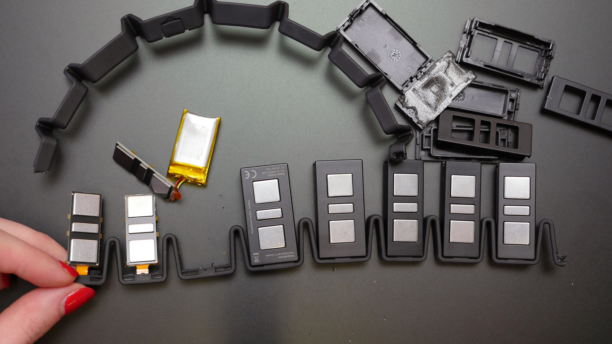

1. EMG sensor modules in Myo armband [5]

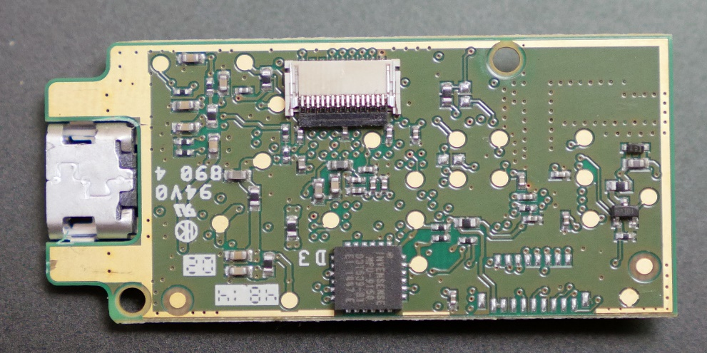

1. Invensense MPU-9150 on the back of the motherboard [5]

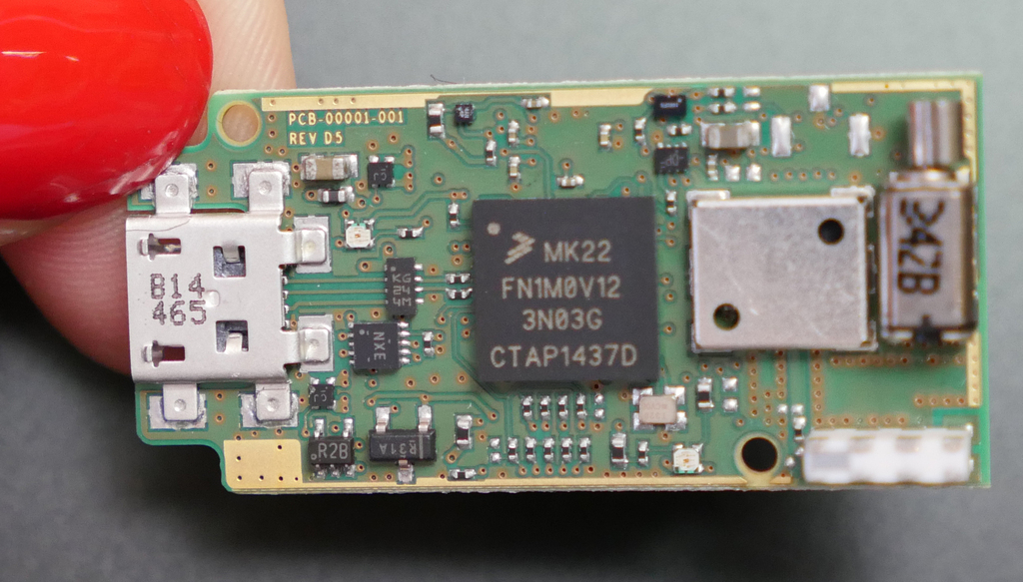

1. Processor for Myo armband [5]

The Myo armband was the sensor of choice for various reasons. First, it was readily available, provided by the Department of Engineering and Aviation Sciences. Thus, it did not cost a thing. Second, it is more than capable of performing human activity recognition on the gesture scale. In a study done by the University of Western Switzerland, the Myo armband was compared side-by-side with more sophisticated EMG sensors. The sensors tested were the Otto Bock 13 E200, the Delsys Trigno Wireless, the Cometa mini-wave, and the Myo armband from Thalmic Labs.

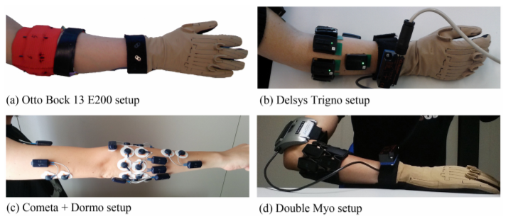

1. Setup for each sensor [6]

The traditional neural network requires large pools of data from which to extract features in a process appropriately named “feature extraction,” which is the process where data is “interpreted” by a neural network. In the previously-mentioned study, the Switzerland-born researchers attempted to develop a machine learning model for recognizing 41 hand movements. They acquired data from different EMG instruments (Otto Bock 13 E200, Delsys Trigno Wireless, Cometa mini-wave, and Myo armband) to train their machine learning model. The performance of the model was evaluated for each EMG device.

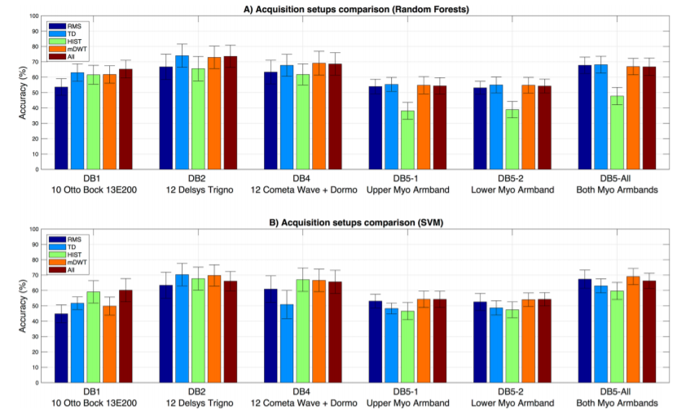

1. Accuracies of 2 models for each EMG device [6]

Two machine learning models were developed and evaluated in the Swiss study. The first model used the Random Forest classifier while the second model was an SVM (support vector machine) model. The Random Forest classifier adopts the design of a traditional decision tree. A decision tree is a series of yes-or-no choices. A machine learning model that uses a decision tree for classification seeks to divide up all available data samples into groups. Each group is associated with its own “branch” of yes-or-no choices. These “choices” are qualities which the machine learning model deems each sample group to have. The Random Forest classifier is more complex than a decision tree because it contains multiple (and, sometimes, nested) decision trees, leading to a deeper understanding of data. Meanwhile, the SVM model is a machine learning model that relies on the concept of “extrapolation” – making inferences from prior information. Specifically, it attempts to locate data points near each other through finding a “hyperplane.” In simple terms, the hyperplane is a boundary that delineates a clear difference between data regardless of its dimension (1D or 3D). The hyperplane is a line in one-dimensional data or a plane in three-dimensional data. It is asymptotic, defining a range through which data points cannot traverse. By finding a hyperplane, an SVM model can pinpoint distinct qualities in different sets of data. This enables it to better classify said data. The Swiss study concluded that, while the best accuracy was achieved through data gathered by the Delsys Trigno, all EMG devices exhibited near-equivalent results, with differences ranges from small to negligible. The Myo armbands were still able to reach accuracy values that rivaled the Delsys Trigno. Although higher accuracy was achieved by the Delsys Trigno through the Random Forest model, the performance difference between the 2 (Delsys and Myo) becomes downright non-existent with the SVM model.

The purpose of citing and giving an overview of the Swiss study was to justify the usage of the Myo armband. Not only is the Myo armband the cheaper option than all other alternatives mentioned in the Swiss study, but it also managed to provide accurate enough EMG data to allow a machine learning model intended for classification to perform adequately. For reference, the cost of the Delsys Trigno is $35,000 while the cost of the Myo armband is a measly $300 in comparison. When attempting to fabricate a product meant for the general populace, the cost of production must be at a reasonable level. Even if your chosen does not offer the *most* optimal performance for the job, all options must be considered and weighed against each other through standardized criteria. Is an accuracy increase of 1-3 percent truly worth $30,000? The answer can vary from project to project depending on the scale of the project and the budget. In the case of Sign AI, this increase in accuracy is too small to warrant its cost.

#### Performing Data Acquisition via Bluetooth & Myo Python

There are 2 methods through which a user can view data (EMG, orientation) from the Myo. The first method is through the Myo diagnostic page located at the following link: http://diagnostics.myo.com. The second is through the Myo Python library created by Nikolas Rosenstein. All documentation related to the Myo Python library can be found on Github and PyPi. As the Myo diagnostics page cannot be web-scraped, the second option was chosen instead. Thanks to the Bluetooth module and dongle, allowing Myo to communicate data to other devices is simple and hassle-free. The remaining hurdle is writing a script to continuously acquire said data.

The Myo Python library has a class known as the Listener class, which borrows from an already-existing class, the Device Listener from the Myo SDK (Standard Development Kit). The Myo SDK was put together by Thalmic Labs and was initially written in the C language. It was later adapted to the Python language by Nikolas Rosenstein in the form of the Myo Python library. The Myo Python library acquires data from the Myo armband through the hub instance. The hub instance establishes communication with the Myo armband until the program in which it was created is terminated. After the hub instance is created, one can now access the attributes of the Listener class such “orientation,” which provides a 4-element quaternion vector calculated from the Myo armband’s IMU), and “EMG,” which provides an 8-element vector containing EMG readings from the armband’s 8 different EMG sensor modules.

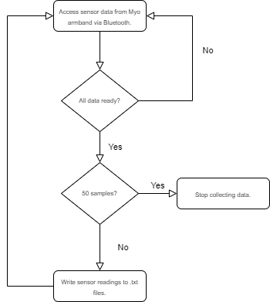

1. The data-logging algorithm

The data-logging will be implemented in Python through the specified algorithm. First, all sensor readings will be documented in their separate text files. Readings from the first EMG sensor module will be placed in a different text file than readings from the eighth EMG sensor module. Similarly, different elements (w, x, y, and z) in the quaternion vector will be stored in their text files as well. 50 samples of each reading will be collected, as 50 samples have proved to be sufficient in capturing the entirety of many gestures. Finally, an indicator that signifies which group of readings were taken from the same instance was implemented in the form of an integer number that is stored in a text file and continuously checked by the program. Acting as a label, this number will be appended to the names of all text files created in a given instance. The number will be used to group them up when it comes time to format all the files for use in the neural network.

### Implementation of Subtask 3

Keep in mind that, for a neural network to be able to process the data given to it, said data must be in the form of an array, the dimension of which depends on the type of layers used in the network. First, the dataset of 10,000 samples was split up into two groups: one dataset (called the training dataset) will be used for training the neural network while the other dataset (called the test or validation dataset) will be used to test the neural network after during each training cycle. The neural network will never see the solutions for the test dataset while the opposite is true for the training dataset.

To transform the text files containing the sensor readings, several steps must be observed. Since all text files are expressed in string or character form, they must be typecasted into their numeric counterparts. This can be easily done in Python. Additionally, since the type of data acquired from the Myo armband is time-series data, how said data is packaged should reflect this as well. Fortunately, arrays are automatically suited for this, as its indices of each of the elements contained in them can substitute for time. One can assume that the indices represent the time difference between the readings. This is not a problem since, like the indices which are spaced out by a constant of 1, EMG is also sampled at a constant rate by the Myo armband. The algorithm used for formatting the sensor data is detailed by the figure on the next page.

The key to formatting the sensor data lies in stacking the readings element-wise and storing them in a master file where the neural network can process them all at once. The “NumPy” library will be used to perform the stacking. Stacking the readings element-wise involves taking an array containing sensor readings from the same instances and storing said array as an element. Every interval of time, the Myo armband acquires many different readings. To represent them properly, these readings must all be stored as a single element. For example, since 50 data points were collected from the Myo armband from different sources of data, each data point must correspond with each other following their order. For example, the first data point from one source must correspond with the first data point taken from another source. A label is appended to the stacked array once all readings are processed. This label represents the gesture performed when the now-stacked readings were taken. All stacked arrays will be stored in a pickle file for ease of access. The benefit of storing the arrays in a pickle file is that they do not lose their format. If the arrays were to be stored in a text file, they would be turned into strings. Accessing them again would require that they are converted back into array form, which overcomplicates things. Storage in a pickle file is beneficial in that it maintains a content’s integrity and simplifies access.

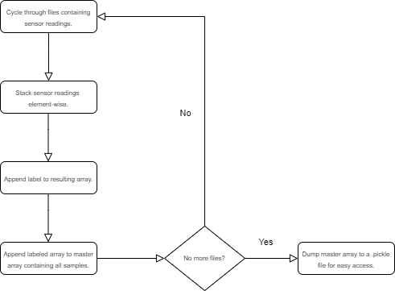

1. The data-formatting algorithm

## Implementation of Task 2

### Implementation of Subtask 1

#### Discussing the Flaws of Traditional Approaches

How data is represented, in addition to the data itself, has an impact on the performance of a neural network. For projects that perform translation of ASL gestures through a neural network, training data is traditionally represented as images of the ASL gestures, transformed into their array counterparts. While this method of visualizing data has produced serviceable outcomes (see Radpour and Bheda’s ConvNet at [7]), it is not a method that is without flaws. To start, it should be noted that static images can successfully depict certain sets of gestures. For these gestures, the final position of the hand is the distinguishing characteristic. Thus, it can be contained in a single frame. However, this is not the case for gestures where rotation or movement is a key characteristic. These gestures cannot be expressed in a single frame. The figures below show the uncanny similarities between 2 gestures. These gestures are “try” and “rock,” respectively. Although the orientations of both gestures are different, the palms are balled up for both gestures. These overlaps in the final hand position will make it hard for the neural network to differentiate between gestures if given that information alone. The reason why most AI-based ASL projects do not venture beyond certain sets of gestures is that the method through which their data is expressed is narrowly focused, suitable for some circumstances but not others. This constraint prevents the neural network from doing translation work on other gestures.

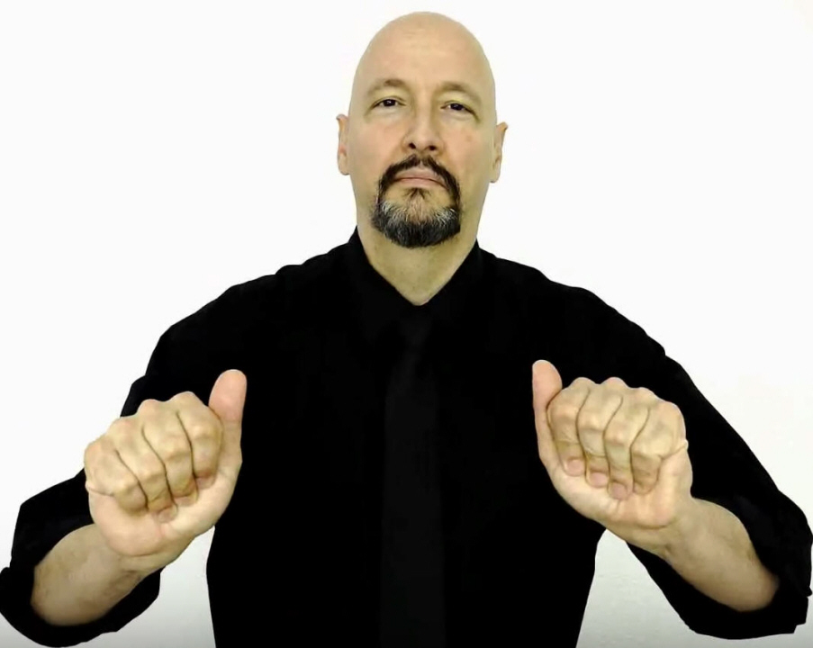

1. ASL for “try” (final hand position) [8]

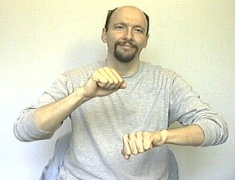

1. ASL for “rock” (final hand position) [8]

Another inherent defect of image data is the presence of image noise, which is all-too-often too hard to decouple from the desired parts of an image. In a paper on techniques for image noise reduction, Indian engineering professors Mythili and Kavitha describe 8 types of image noise in great detail: amplifier noise (Gaussian noise), salt-and-pepper noise (impulse noise), shot noise, quantization noise (uniform noise), film grain, on-isotropic noise, speckle noise (multiplicative noise), and periodic noise. Although some discussion is devoted to each category of noise, discussions on impulse noise, gaussian noise, and speckle noise are particularly lengthy, as these are the most common types of image noise found in images.

The first type of noise discussed by the paper is amplifier noise (or Gaussian noise), wherein it is stated that amplifier noise is “additive” [9]. Mathematically speaking, Mythili and Kavitha disclose that, in ideal cases, amplifier noise can be quite easily modeled by a Gaussian distribution. Armed with this information, various filters have been developed and implemented by DSP (digital signal processing) researchers to combat it. On the fundamental level, amplifier noise is a noise that adds a bias to the original red, green, and blue values of an image signal. The second commonplace noise type that is discussed in Mythili’s and Kavitha’s paper is impulse noise or salt-and-pepper noise, which is similar in some ways to the amplifier or Gaussian noise. In Gaussian noise, the image is affected as a whole. However, in impulse noise, a select number of pixels are affected, which makes them stand out from the rest. The primary difference between Gaussian noise and impulse noise is that impulse noise is smaller in scale and caused on the hardware side. Hardware mishaps that lead to impulse noise include non-functional analog-to-digital converters in cameras, overheating of equipment, and dust in lenses. The final noise type covered in detail by Mythili and Kavitha is speckle noise, which, unlike Gaussian noise, is multiplicative rather than additive. In particular, satellite and radar technologies are said to be more acutely affected by speckle noise, as it is a direct result of interference from the surrounding area. Image-capturing hardware ranging from mundane devices like cameras to more sophisticated contraptions such as the Synthetic Aperture Radar relies on the concept of backscattering. In the case of the Synthetic Aperture Radar, an image is captured through a mixture of steps involving the radar itself and the specimen. First, the radar illuminates the specimen with a light of its own. Then, sensors on the radar pick up the light that is reflected in it. This back-and-forth interaction between the radar and the specimen is known as backscattering. Once the reflection is received by the radar, it is then processed digitally; based on this reflection, the radar reconstructs its version of the specimen.

In the concept of backscattering, the parameter that matters most is the energy that is reflected by the specimen. An article by NASA on radar technology reveals that the energy of the echoed photon signal can determine the brightness of an image that is produced. Specifically, it states that “bright features mean that a large fraction of the radar energy was reflected by the radar, while dark features imply that very little energy was reflected” [10]. In addition to the energy of the reflected signal, there are also environmental and material-specific factors that can influence the quality of an image. For example, in radar images, specimens that contain more water generally appear brighter than their dry counterparts. This is because water affects an object’s electrical properties. When water molecules come into contact with an object, they cohere with other molecules and form a barrier on top of the skin. The resistance of the skin is reduced because it is connected in parallel to the layer of water. Variance in a specimen’s resistance can also dictate if an object appears brighter or darker in a radar image.

Radars and cameras are similar in that backscattering can affect the quality of images that both produce. For cameras, the negative impacts of backscattering can be particularly observed in images where small obstructions such as droplets of water appear as clear or white imperfections. Whenever there are small particles littered about in the frame of a camera, the chance of producing an image with undesirable affectations increases drastically. In addition to water droplets, fine substances like dust or sand can also produce similar affectations in an image. The factor that influences these affectations is distance. According to the Inverse-Square Law, light is reflected more strongly if it is closer to its source. By being closer to the camera lens, the water droplets in the figure above appear brighter and more prominent than the rest of the image.

Image noise is the prevailing reason why data from image-capturing devices proves to be unreliable for use in a neural network. There are simply too many factors – some controllable, while others not – that can affect image data from image-capturing devices. It will take a lot of work just to pre-process the data and isolate the desired parts. Even if a researcher decides to train the neural network to be able to recognize noise from the gestures, it will take a large pool of data to tackle such a complicated problem. The complication is due in large part by the various types of noise that can exist in a single image. To be able to recognize them all, a neural network would need an abundant number of samples. Otherwise, the alternative would be to develop numerous robust filters capable of suppressing noise to an acceptable but preferably ideal level.

#### Transforming Gestures to EMG and Quaternions

The Myo armband will be used to acquire information for the classification neural network. Although the armband is meant to be employed as a wireless control for computing devices such as laptops and personal computers (PC), in the development of an ASL translation tool, it will fulfill a different purpose. The Myo armband is equipped with a variety of sensors meant for detecting gestures performed by a user. It has 8 EMG sensor modules to measure muscle activation and a 9-axis inertial measurement unit to estimate its orientation in space through calculating quaternions. It should be noted that the Myo armband has already pre-programmed to recognize a set of 5 gestures: wave right, wave left, double-tap, fist, and fingers spread. The sensors of Myo provide 2 crucial pieces of information to the neural network regarding each gesture: the location of the muscles that are activated for each gesture and the motion of the hand when certain gestures are performed. The information received regarding a gesture’s time-series EMG and orientation help the Myo discern what gesture is being performed. In theory, this quality should make the Myo suitable for learning ASL as well. Later sections of the paper will discuss the means through which data is acquired from the Myo armband.

### Implementation of Subtask 2

#### Discussing the Merits of the LSTM (Long-Short Term Memory) Model

The LSTM model falls under the umbrella of the recurrent neural network (RNN). For context, the RNN is a type of neural network that excels in processing sequences of data. It can do this by transmitting prior information to later parts of a neural network. Most neural networks are feed-forward networks, meaning that information flows in a single direction. Every layer in a feed-forward neural network produces outputs that other layers are not able to access. The other layers are not told how these outputs are produced. This is where the RNN begins to diverge from the traditional feed-forward neural network. The RNN interconnects outputs of layers by relaying said outputs from one layer to the next through a loop. Prior information is known as the “hidden state” in the realm of deep learning. The hidden state relays more than just the outputs of a previous layer. It also describes how previous outputs have changed over time while in previous layers. RNNs have layers with feedback loops, and this is where the hidden state is passed on and updated. In an RNN, the hidden state of a previous layer can affect the outputs of the following layers because it is processed in conjunction with the inputs of the following layers.

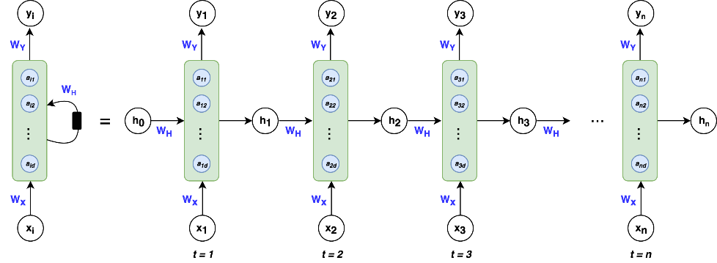

1. A simple RNN layer [11]

The specialty of the LSTM model is memorizing long-term dependencies or patterns in data. There are mechanisms within an LSTM layer that allows it to keep track of dependencies. In an LSTM layer, two elements are responsible for memorization: the cell state and the gates. For reference, the terms “cell state” and “hidden state” can be used interchangeably. The cell state is an additional output produced by an LSTM layer. It is where changes in the input are documented. The cell state and gates go hand-in-hand in that the gates are responsible for updating the cell state. In short, the “gates” are activation functions that have a binary range, meaning their outputs lie between 0 and 1. An output of 0 indicates that the input did not change. Therefore, the cell state is not updated. The opposite is true if the gates produce a result of 1.

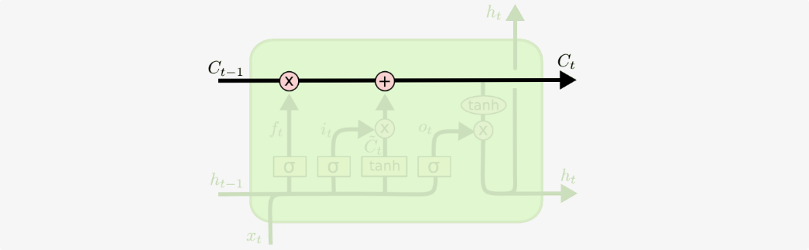

1. The cell state, highlighted in a diagram of an LSTM layer [12]



1. The “gates,” denoted by a lowercase sigma (σ) [12]

What separates the LSTM model from a run-of-the-mill RNN is the ability to update the cell state by adding *and* removing information through the gates. A single LSTM layer contains 3 gates. The first gate – a sigmoid activation function – is known as the “forget” gate. True to its name, it removes information from the cell state once it receives the “okay” to do so. This “okay” comes in the form of a “0” output. If the state of the “forget” gate is one, the cell state will remain unmodified. For understanding, an activation function is called an “activation” function because its job is to “activate” values in a layer. This “activation” comes in the form of analyzing endless streams of values and determining through a binary decision which values should be kept. Information is removed from the cell state through a bitwise AND operation between it and the “forget” gate.

Following the “forget” gate is the “update” gate. True to its name, it is responsible for adding information to the cell state. Similar to the “forget” gate, the “update” uses the bitwise AND operation to change the contents in the cell state. The one difference is the presence of the hyperbolic tangent, which scales the added content to a comfortable range that is easier to manage by the neural network. The hyperbolic tangent was not necessary for the “forget” gate, as it was not adding information to the cell state.

The final gate (rightmost) in an LSTM layer is the “output” gate. To put it simply, the “output” gate determines the output of an LSTM layer. Two activation functions are used in this gate. The first activation function is the sigmoid activation function, which is denoted by a lowercase sigma. The second activation is the hyperbolic tangent, which works side-by-side with the first activation function. The sigmoid layer will filter the cell state and keep the relevant values. Meanwhile, the hyperbolic function will be used to scale the cell state between a range of -1 and 1. Having a localized range makes computation easier for the neural network.

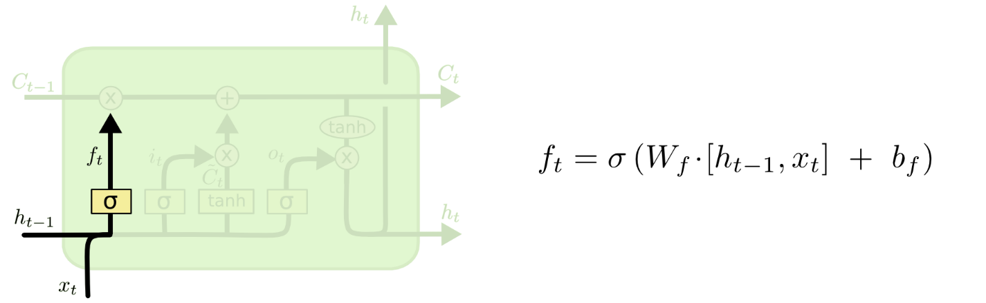

1. “Forget” gate, highlighted in a diagram of an LSTM layer [12]

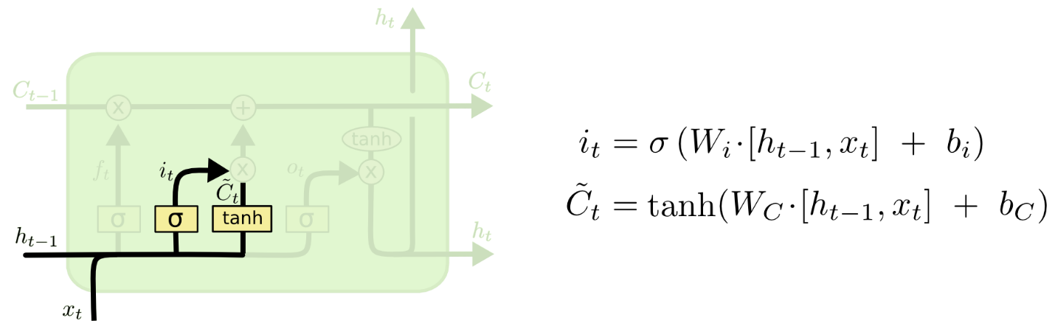

1. “Update” gate, highlighted in a diagram of an LSTM layer [12]

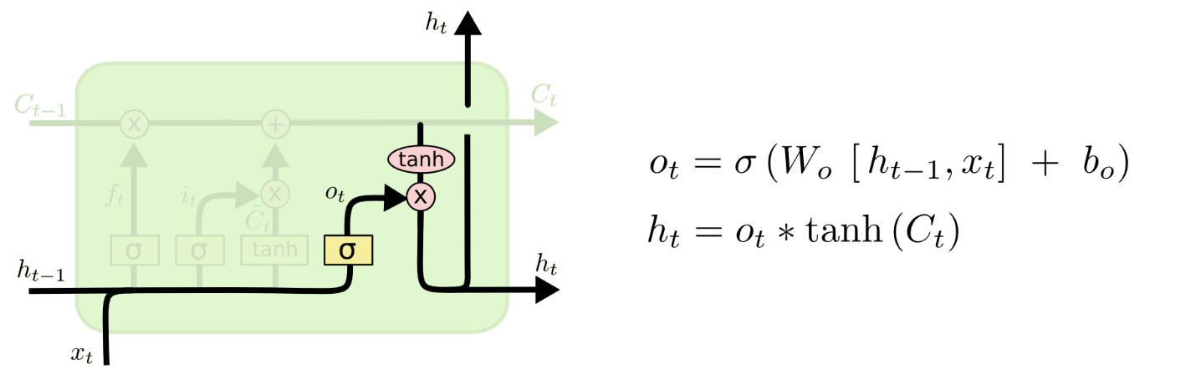

1. “Output” gate, highlighted in a diagram of an LSTM layer [12]

### Implementation of Subtask 3

Is the LSTM model suitable for gesture classification? The answer is a resounding “yes.” When one is considering the architecture of a neural network, one must also consider the data that will be processed by said architecture. There is a correspondence between the architecture and the processed data. The processed data will relay important information to the network, while the network interprets relayed data and outputs a value that represents it. The factor that determines if a network is suitable for solving a problem is its ability to interpret the input data. What information is hidden in the data? Are there patterns or dependencies? What is the size of the data? Does the data vary with time? Is the proposed network capable of understanding the subtext in the data? The following questions bring up some important considerations. In all considerations, the bottom line is that the neural network must be able to “read between the lines” and decipher desired chunks of information.

What makes the LSTM model suitable for gesture classification? The answer lies in its ability to memorize long-term patterns and dependencies. Recall that the LSTM model contains layers that update themselves based on the changes that the input data undergoes in the network. These “updates” are representative of the patterns and dependencies that the network has extracted after processing the input data. The input data will come in the form of readings from EMG sensors and a 9-axis IMU. These readings vary with time and correspond to a gesture. The job of the neural network is to determine the performed ASL gesture based on the aforementioned readings. To be successful, it will need to keep track of changes in the sensor readings. In other words, it will need to memorize patterns and dependencies. This need is fully met by the LSTM model, due in large part to its design and intended function.

## Implementation of Task 3

### Implementation of Subtasks 1 and 2

#### Discussing the Merits of the Keras API for Tensorflow

The realm of deep learning has been gaining traction over the years. For one, the result of decades of progress has culminated in the development of sophisticated AI like Sophia, a robot AI which is capable of holding complex conversations and stringing together human-like sentences. Perhaps the most profound effect of the increasing prominence of AI lies not in the new technologies, but in the development of tools which simplify the process of creating an AI. TensorFlow is one such tool. TensorFlow is an open-source Python library containing pre-programmed functions meant for designing, testing, and exporting neural networks. For many beginner AI developers, TensorFlow is usually accompanied by the Keras API, which simplifies the AI development process even further. The Keras API allows users to define layers in a neural network sequentially using the “Sequential” and “add” functions. Also, the Keras API wraps many lines of pure TensorFlow code into singular, compact lines for ease of use. However, some customizability is sacrificed as a result. Because both Keras and TensorFlow are user-friendly, well-supported, and well-maintained, they will be used to develop a gesture recognition neural network.

#### Training a Model in TensorFlow Using the Keras API

In Sign AI, both Tensorflow and the Keras API will be used to create and train the neural network. This section will devote a thorough discussion in the use of each software, most of all including a discussion of the code necessary to operate a neural network. As mentioned before, the Keras API enables the initialization of a sequential model in Tensorflow. Usually, in pure Tensorflow code, the user is expected to define the neural network on their own. This means that the user is responsible for creating the scheme for updating weights, as well as the mechanisms of each specialized layer in their neural network. Such a thing is not ideal for people who are not data scientists or who are not well-versed in the theory of neural networks. Not to mention, it also requires familiarity with Tensorflow code. To simplify the process of creating neural networks, the developers of the Keras API wrote a set of special functions that do most of the programming for the user. One of these special functions is the “Sequential” function, which on its own initializes a neural network already equipped with the ability to update its weights. The syntax of the “Sequential” function is as follows:

1. **from** Keras.models **import** Sequential
3. model = Sequential()
4. Initializing a neural network through Keras

As one can see, the “Sequential” function does not take any parameters at all. Its job is plain and simple: to program the complicated mechanisms of the neural network for the user. The sequential model is special in that it allows the user to conveniently specify layers in their neural network as well as any properties the layers have. Once a sequential model is created, several other functions are afforded to the user. One of these functions is the “add” function, which can be accessed by a Keras-initiated sequential model. The “add” function does exactly what its name suggests: add a layer to the sequential neural network. The syntax of the “add” function is as follows:

1. **from** Keras.models **import** Sequential
2. **from** Keras.layers **import** LSTM
4. model = Sequential()
5. model.add(LSTM(128, input_shape=(50,12)))
6. Adding a layer to a sequential model

Every neural network has an input layer and an output layer. These layers serve specific but straightforward purposes in the neural network. The input layer can be any kind of layer. In this case, the input layer is an LSTM layer. However, for the input layer, the user must specify the size of the input going to it. Keras made it so that the input size needs to be declared just once in the input layer. The convenience of this lies in the input size being implicitly inferred by other layers based on the input size declared in the input layer. On the other hand, the output layer is where the prediction of the neural network is produced. The number of nodes in the output layer is congruent with the total number of possible predictions. If the input and output layers are configured correctly, the user can add as many layers as desired in the neural network. The finished code for the neural network is written below:

1. # defining the LSTM neural network.
2. model = Sequential()
3. model.add(LSTM(128, return_sequences=True, input_shape=(50,12)))
4. model.add(LSTM(128))
5. model.add(BatchNormalization())
6. model.add(Dropout(0.5))
7. model.add(Dense(100, activation='softmax'))
8. Fully defining the neural network in the codespace

To stack LSTM layers, the “return sequences” parameter must be set to true. The “return sequences” parameter ensures that the dimensions of the input shape are maintained throughout the LSTMs. Keep in mind that the LSTM layer takes a multi-dimensional array as an input. If the “return sequences” parameter is not set to true, the neural network assumes that the subsequent layers are fully-connected or dense layers, which are layers that only process one-dimensional arrays. The original input is reshaped into a one-dimensional input before it is handed off to these layers. A one-dimensional input inadvertently being passed to an LSTM layer will cause an exception to raise, warning the user of input incompatibility.

Specifying the activation function is also important in neural networks. These are included as parameters in the layers. In basic terms, activation functions are the gatekeepers of the neural network. It facilitates the network’s learning process by determining which parts of the input are propagated in the network. Undoubtedly, this can influence the output of the neural network. There are many different types of activations functions, and some are used experimentally for some layers. However, there is a rule of thumb concerning which activation functions are used for each layer. For layers that take multi-dimensional inputs, these layers are activated by non-linear activation functions. Non-linear activation functions can be used by backpropagation to update weights as the derivatives of these activation functions are not constant and can be used to influence the adjusting of weights for better predictions. For all fully-connected or dense layers, the activation functions are always linear. If it is the output layer, the activation function is the softmax function. If it is an intermediary layer, the activation function is a rectified linear function. For some layers in Keras such as the LSTM layer, the activation function cannot be customized, or else it will compromise the performance of the layer.

Defining the neural network architecture is the first step in the training process. The second and final step of the process is compiling the defined architecture and feeding it with the necessary information for training. The former is done through the aptly named “compile” function. The “compile” function takes several mandatory arguments before it can put together the specified neural network architecture for training. The first of these arguments is the “loss” arguments, which declares the cost function to be used to measure the performance of the neural network. To recap, the loss function is an indication of the neural network’s ability to make correct predictions. If a neural network is navigating the loss function downwards, it suggests that the overall error between the neural network’s prediction and the ground truth is getting smaller. The cost function is also used to adjust weights as the weights of the neural network are one of the many parameters of the cost functions. The weights determine the landscape of the loss function. For reference, the terms “cost” and “loss” are often used interchangeably in deep learning discussions. On the other hand, the second and final mandatory argument in the “compile” function is the “optimizer” argument. Recall that the optimizer is an algorithm to aid in the spelunking of the loss function. The optimizer will do its best to aid the neural network in attaining as small a loss as possible. For multi-class neural networks such as the one that will be implemented in the paper, the standard loss function is the sparse cross-entropy function. The code for compiling a neural network is listed below:

1. model.compile(loss='sparse_categorical_crossentropy', optimizer="nadam")
2. Packaging the finished neural network using the “compile” function

Following the “compile” function, the neural network is now completely defined in the eyes of Keras. Next, the training process must be initialized. This is done through the “fit” function, which, like the “compile” function, intakes several mandatory arguments: training dataset, validation dataset (if any), batch size, and the number of training cycles (called “epochs” in Keras). The training dataset can be formatted in any way the user desires, so long as it is in a format that the neural network can read. Also, every sample in the training dataset must be compiled into a single file. This file is what will be passed to the training dataset argument. The training dataset will be the dataset that the neural network will extract hidden information or “features” from. For every training cycle, the neural network compares its prediction with the ground truth and adjusts its weights depending on how far off its prediction was. On the other hand, for the validation dataset, the neural network does not have the luxury of seeing the solutions. The validation dataset is a separate dataset with which the neural network tests itself after every training cycle. The neural network’s performance on the validation dataset is usually a good indicator of whether or not the network is overfitting. Like the training dataset, all samples of the validation dataset must be compiled into one file. As a parameter that determines how samples are handled, the batch size argument declares the number of samples handled per instance. Gradients are calculated after each batch by Keras, so the batch size should be tuned to the right amount (not too small that the gradients are too specific to one case or sample, but not too large that too many cases are covered at once). Finally, the epoch argument specifies how long the training will occur. Great care must be taken not to prolong the training process than necessary, as this will often cause the weights of the network to overfit. The code for initiating the training of a neural network is listed below:

1. # preparing training data for use in NN.
2. pickle_out_samp = pickle.load(open("samples-train-final-2.pickle", "rb"))
3. pickle_out_sol = pickle.load(open("solutions-train-final-2.pickle", "rb"))
5. # preparing validation data for use in NN.
6. pickle_out_samp_val = pickle.load(open("samples-val-final-2.pickle", "rb"))
7. pickle_out_sol_val = pickle.load(open("solutions-val-final-2.pickle", "rb"))
8. # fit network.
9. history = model.fit(pickle_out_samp, pickle_out_sol, batch_size=64, epochs=300,
10. callbacks=callbacks_list, verbose=1,
11. validation_data=(pickle_out_samp_val, pickle_out_sol_val), shuffle=True)
12. Initiating the training process in Keras

Keras also contains additional features that can be used to facilitate the training process or improve the performance of the neural network. These additional features can be specified in the “callbacks” argument of the “fit” function. Some of these additional features include early stopping, saving the best model, and cutting down the learning rate of the neural network if its performance is not improving.

### Implementation of Subtask 3

#### Discussing the Merits of Stacked LSTM Layers

In the Herman and Schrauwen paper (titled “Training and Analyzing Deep Recurrent Neural Networks”), some background was explored regarding the default depth of a single layer in an RNN: “when folded out in time, it [RNN] can be considered as a DNN with indefinitely many layers” [13]. A DNN is an abbreviation used to describe deep neural networks. Herman and Schrauwen claim that an RNN is, in their opinion, a DNN that possesses infinite layers. The “infinite layers” commentary refers to the basic structure of an RNN. A layer of an RNN has an internal memory that enables it to process data sequences. This internal memory is known as the “cell state.” Variants of the RNN like the LSTM RNN also have cell states. The cell state is updated through feedback loops in an RNN that propagates new and old information. If the input data is infinitely long, then data is infinitely propagated through a layer, making the RNN infinitely deep. Herman and Schrauder were alluding to the persistent nature of the RNN by saying it is “infinitely deep.”

Later in the paper, Herman and Schrauder delve into the design of an RNN, particularly the logic behind it: “For RNNs, the primary function of the layers is to introduce memory, not hierarchical processing.” Hierarchical processing in neural networks is the idea that new knowledge is extracted at each layer. Herman and Schrauder believe that hierarchical processing is not the aim of an RNN. They also believe that shallow hierarchical processing can limit an RNN’s performance, even listing several performance-affecting limitations: “Common RNNs do not explicitly support multiple time scales, and any temporal hierarchy that is present in the input signal needs to be embedded implicitly in the network dynamics” [13]. Herman and Schrauder are making the following assertions: that the RNN does not excel in hierarchical processing, which can affect its understanding of the input, and that the RNN is not by default capable of analyzing data piece-wise concerning time. To address these concerns, the following proposition was made and later verified: “The architecture we study in this paper is essentially a common DNN (a multilayer perceptron) with temporal feedback loops in each layer, which we call a deep recurrent neural network (DRNN). Each network update, new information travels up the hierarchy, and temporal context is added in each layer. As we will show, stacking RNNs automatically creates different time scales at different levels, and therefore a temporal hierarchy” [13]. Essentially, Herman and Schrauder are proposing a fusion of the DNN and RNN. Dense layers will be used to increase hierarchical processing, while RNNs will be stacked to give temporal context to the input data at different instances of time.

Due to the benefits of increased hierarchical processing and temporal context, our paper will be adopting Herman and Schrauder’s architecture. To recap, the Myo armband will be providing multiple sensor readings to the neural network, some different types. Specifically, EMG and orientation data will be used by the network to classify ASL gestures. If the network lacks hierarchical processing, it will not be able to understand the spatial context between the readings. Here, “spatial context” refers to the knowledge of which sensor produces which reading. Also, without the memory of an RNN layer, the temporal context will be lost. This means that the network will be unable to recognize time-based patterns. Herman and Schrauder’s architecture combines the hierarchical processing of DNNs and the temporal context from RNNs to process data from multiple perspectives.

#### Discussing the Merits of Using Dropout

By all accounts, a stacked LSTM model is a large neural network. This can be problematic if the dataset used for training is small. Having a large neural network but a small dataset is one indicator of overfitting. The Sign AI project has 100 labels, with each label corresponding to an ASL gesture. Each label contains 100 samples, resulting in 10,000 overall samples. The label-to-sample ratio is 1:100. While no standard defines a “small” or “large” dataset, it is preferred to have more samples. More samples suggest that the dataset is diversified, covering data containing differentiations variations with which to train the network. The dropout layer is one age-old defense against overfitting. Its merits are discussed in depth in “Dropout: A Simple Way to Prevent Neural Networks from Overfitting” written by Hinton et al.

Deep neural networks are beneficial in that they can learn complicated relationships. This is corroborated by Hinton et al., who state that having multiple layers help the network recognize underlying connections between inputs and outputs. In addition to its architecture, a neural network also relies on training data, which is dissected for hidden information. Ideal circumstances mean that training data in abundance. However, this is not always the case. A limited dataset can cause a neural network to overfit without proper regularization, which is a means of increasing a network’s ability to “generalize.” If a network is capable of “generalizing,” then it can handle data that it has not been trained with. A network not capable of generalizing is considered to be “overfit.” Training a neural network involves micro-managing weights and biases, both of which are parameters that dictate the network’s response to inputs. At every epoch or training cycle, weights and biases are constantly overwritten in an attempt to find the most ideal values. There are many reasons behind an overfit model. One obvious culprit is the number of epochs. If the neural network is exposed to the training data for a long time, it will start to develop weights that respond well to the training data but no other data than that. In other words, the neural network will perform poorly when processing data it has not been trained with.

An often-used form of regularization, the dropout method is a method that randomly disables nodes in a layer (or layers) of a neural network. In the Keras API, one can specify the percentage of nodes to be disabled by passing it as an argument to the dropout layer. Figure 26 shows how the disabling of nodes can affect the propagation of information in a network. As discussed in Hinton et al.’s paper, there is a biological basis behind the dropout method, one rooted in the topic of genetics and the passing of genes: “The role of sexual reproduction is not just to allow useful new genes to spread throughout the population, but also to facilitate this process by reducing complex co-adaptations that would reduce the chance of a new gene improving the fitness of an individual” [14]. In the following excerpt from Hinton et al.’s paper, the role of dropout in a neural network is explained through the concept of natural selection. The keywords are “reduction” and “co-adaptations.” In biology, evolution forces individuals to develop new genes. These genes are supposed to help humans develop advantageous characteristics. The end goal is to develop new *and* advantageous genes. This is done by minimizing interplay between genes, known as biological co-adaptations. Co-adaptation is a phenomenon in which a person’s characteristics are determined by a gene pair. Each gene relies on its counterpart to remain functional. These dependencies between genes are not desirable as they create multiple points of failure. Co-adaptation also exists in neural networks in the form of dependencies between layers. Co-adaptations between layers in a neural network can be minimized through dropout. Each layer feeds information into future layers, which can create unwanted or unintended dependencies between layers and cause the neural network to overfit [14]. One way to reduce these dependencies is by preventing small chunks of information from reaching future layers, which the dropout method accomplishes through shutting down nodes. The logic behind the dropout layer is to force layers to be more self-reliant and infer the missing information themselves [14].

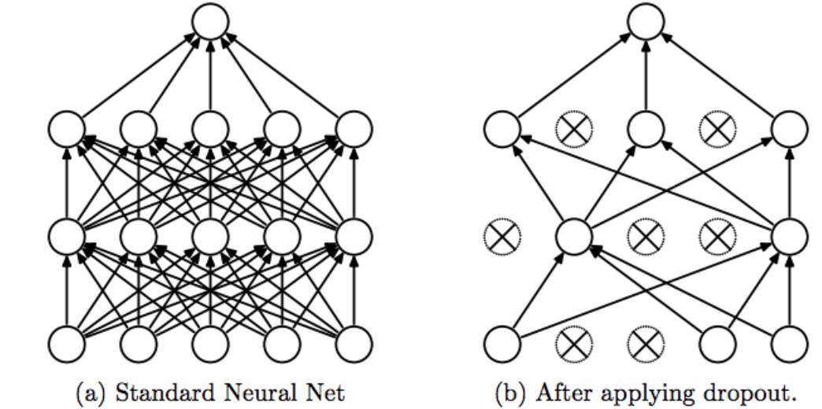

1. Comparison of a layer with and without dropout [15]

#### Discussing the Merits of Using Batch Normalization

In the context of neural networks, batch normalization is a method of standardizing inputs. Batch normalization addresses several problems related to the performance and training of a neural network. A paper written by Sergey Ioffe and Christian Szegedy (titled “Batch Normalization: Accelerating Deep Network Training by Reducing Internal Covariate Shift”) discusses the merits of batch normalization in explicit detail. The internal covariate shift is touted by Ioffe and Szegedy as something negative, harming a neural network. Ioffe and Szegedy justify their claim by bringing up the distribution of inputs in layers: “The change in the distributions of layers’ inputs presents a problem because the layers need to continuously adapt to the new distribution. When the input distribution to a learning system changes, it is said to experience a covariate shift” [16]. Ioffe and Szegedy define internal covariate shift as the inevitable changes in the flow of information from layer to layer.

Before one can understand the impact of batch normalization on a neural network, one must first understand how its weights are updated. In a neural network, data flows forwards and backward. The backward flow of data is called “backpropagation.” The job of a neural network is to map inputs to appropriate outputs. During training, outputs are pre-determined. The important parameter is the network’s prediction. Weights are updated depending on the exactness of the prediction. How is this “exactness” quantified? The answer lies in the concept of error. Error needs to be calculated for every node in a network and sent back for processing. This “sending back” is backpropagation at work. It is an algorithm that calculates the gradient of the partial derivative of the cost function concerning the network’s weights. For reference, the term “cost” is synonymous with “error” and “loss.” Figure 27 illustrates backpropagation in its simplest form, the comparison of the expected and predicted values passed along to previous layers of a network.

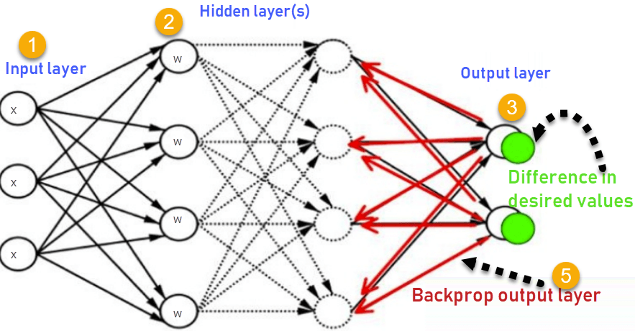

1. Backpropagation at work [17]

How does batch normalization benefit the neural network? Batch normalization is, in essence, a rescaling of the weights to a localized range. Ioffe and Szegedy mention in their paper a phenomenon called “internal covariance shift,” explaining that the purpose of batch normalization is to minimize the influence of such a shift. First, what is the “internal covariance shift”? Ioffe and Szegedy explain it as the variations in the outputs of each node in a layer, which are received as inputs by other nodes from another layer [16]. These variations are thought to worsen as parameters such as weights and biases are updated for every layer in a network. The particular term Ioffe and Szegedy use for the outputs of the nodes is “hidden unit values.” Also, rather than using the word “variation,” the more accurate word would be “distribution.” As weights and biases of previous layer change, so do the distribution of inputs that enter the subsequent layers in a neural network. Changes in input distributions can cause the network’s performance to shift wildly, as the network has to continuously accommodate for new input distributions. With Batch Normalization, the stability of input distributions is increased as all hidden unit values in the affected layers are made to have zero mean and unit variance. To be more specific, the hidden unit values are forced to conform to a standard normal distribution.

There have been papers written that conflict with Ioffe and Szegedy’s ideas, however. One paper written by MIT Ph.D. students argues with proof that the purpose of batch normalization is not to reduce the internal covariance shift of a neural network in any way [18]. An experiment was conducted in the paper that proves this is not the case. One of the primary objectives of the paper was to verify the connection between the reduction in the ICS (abbreviation for “internal covariate shift”) and batch normalization. The experiment conducted by the paper involved training networks where noise is injected to disturb input distributions. The reason for injecting noise is rather clear from the authors’ perspective: to create the effect of skewed input distributions. With the implementation of batch normalization layers in their network, the authors (Ilyas et al.) sought to prove or disprove the supposed “power” of batch normalization to fix the uneven distributions and thereby reduce the ICS (which is expected to increase the network’s performance as a result). Ilyas et al. discovered that, while the normalized network performed better than the non-normalized networks, it was not due to a reduction in the ICS that this was so [18]. The batch normalization layers did little in addressing input distributions [18]. Ilyas et al. were thorough in their experiment, comparing the performance of a normalized network with noise injected against a normalized network without noise. Despite having “less stable (input) distribution,” the network with the injected noise displayed better performance than its noiseless counterpart [18]. The connection between improved performance and reduction in the ICS is not substantiated in practice. Ilyas et al. also proposed their ideas on the exact effect of batch normalization; an additional experiment was also conducted to prove or disprove it. According to Ilyas et al., the merit of batch normalization lies in a rather fundamental concept. Ilyas et al. state that the reason why batch normalization is so effective is because of its reparameterization of the “underlying optimization problem” being solved by the neural network during training [18].

One might ask: what is the optimization problem that the neural network is solving? The answer lies in the gradient of the cost function. Recall that the goal of training a neural network is to reduce errors in predictions, which means navigating the cost function towards its global minima. How does the neural network determine that the error has been reduced? It does so by looking at the gradient, which is an expression for the rate of change of *something*. After all, a gradient is simply a partial derivative. The gradient tells the neural network which direction it is traveling the cost function. Since Ilyas et al. have stated that batch normalization makes the gradient “more predictive and well-behaved,” the network will display more stable performance during training as it knows with more certainty where it is going [18]. “Well-behaved” in this case is a reflection of the gradient’s “Lipschitzness” as mentioned by Ilyas et al [18]. The mathematical concept of Lipschitzness deals with gauging a function’s continuity, the criteria used by Ilyas et al. to measure “smoothness.” More continuous functions tend to have fewer regions where the change from one value to another value is too significant and abrupt. A continuous function *looks* more connected and is, therefore, more “smooth.” In short, smoother gradients are beneficial because of their continuity.

#### Formulating the Finalized Neural Network

The final version of the neural network consisted of two stacked LSTM layers containing 128 nodes and a dense layer with 100 nodes for the output layer. Recurrent dropout was applied to the LSTM layers. A batch normalization layer followed by a dropout layer was placed after the stacked LSTM layers. The decision to stack 2 LSTM layers was discovered through trial-and-error. Stacking 3 or more LSTMs generally led to worse performance, while not stacking at all made the network too shallow. The best performance was observed when 2 LSTMs were stacked. The parameters of the finished neural network are detailed in Table 2.

1. **Parameters of Finalized Neural Network**

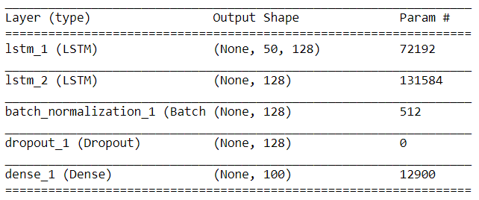

#### Discussing Model Performance

When evaluating the performance of a neural network, one must examine 2 parameters: loss and accuracy. The loss of a neural network is a number indicative of the network’s tendency to make prediction mistakes, while its accuracy describes in percentage form its success in making predictions. There is a relationship between loss and accuracy that can tip off signs of overfitting. Recall that there are 2 datasets that the neural network must be able to solve: the training dataset and the test or validation dataset. The neural network sees the solutions to the training dataset, so it can compare its prediction to said solutions. However, the solutions to the validation dataset are not visible to the neural network, which means that the loss and accuracy of the validation dataset are more indicative of the network’s true performance. The accuracies and losses of both datasets during training are illustrated in Figures 27 and 28.

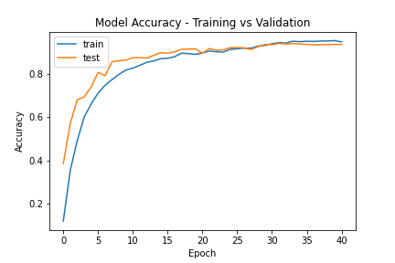

1. Comparing the accuracy of the neural network in 2 datasets (train and test)

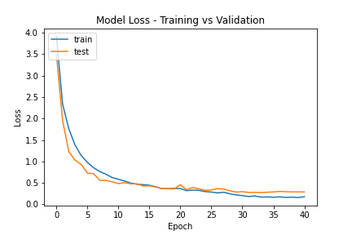

1. Comparing the accuracy of the neural network in 2 datasets (train and test)

For reference, the training dataset is 8000 samples large while the validation set is 2000 samples large. When there are significant differences between the training outcomes and the validation outcomes, this should raise flags that the neural network is overfitting. Thusly, several methods of regularization were used to prevent the neural network from overfitting. Among these methods, dropout and weight constraints were used. Dropout regularization was employed through adding dropout layers in the neural network, while weights constraints required the use of the “max norm” function from the Keras library. As discussed before, the benefit of dropout lies in the ridding of dependencies between layers and forcing layers to “think for themselves.” This is done through disabling nodes in a layer, ensuring that not all information will flow to the subsequent layers. On the other hand, max norm regularization involves ensuring that weights stay within a specified range. Keras checks each weight and rescales the weights which exceed the constraint put on them.

Another factor that affects the weights of the neural network is the learning rate. The responsibility of the learning rate is to dictate the factor by which weights change per batch of data that the network is trained with. To maximize performance, the learning rate was artificially manipulated through the use of the Keras “reduce LR on plateau” function. The “reduce LR on plateau” function takes in several mandatory arguments: monitor, factor, min LR, and patience. The “monitor” argument describes the metric by which one is evaluating the neural network (loss, accuracy, etc.). Meanwhile, the “factor” argument describes the number by which the learning rate will be divided if the monitored metric does not improve within a specified amount of training cycles. The amount of training cycles before the learning rate is changed is decided by the integer passed to the “patience” argument. The logic behind reducing the learning rate is as follows: the training of the neural network leads to the development of better weights, and, sometimes, to attain better performance, these weights must be tuned to a finer degree. This necessitates the use of a smaller learning rate, which means that the weights do not change as dramatically as before.

Keras offers many functions that assist in the creation of better-performing neural networks. Another of these functions is the “early stopping” function, which, as its name suggests, cuts short the training of a neural network once it has stopped showing signs of improvement. Early stopping takes in similar arguments as the “reduce LR on plateau” function; it has a “monitor” argument and “patience” argument. Depending on the user’s specifications, the training of the neural network can be long or short. In addition to the “early stopping” function, the “save best model” function was used to capture improvements of the neural network. Simply put, every time the neural network exhibits improvement in the monitored metric, its current state is saved as a file that can be loaded in the future. This file contains all the information necessary (architecture, weights, etc.) to reconstruct the neural network.

Given the limited dataset and the regularization methods used, the final performance of the neural network turned out better than expected. With 100 gestures to distinguish between, the neural network certainly had its work cut out for it. A famous gradient descent optimizer was used to speed up the training process: the “Nadam” optimizer. “Nadam” is shorthand for the Nesterov-accelerated version of the adaptive moment estimation algorithm. Recall that the job of the gradient is to let the neural know where and how it is navigating the loss function. Optimizers like Nadam aid in this endeavor by affecting the updates made to the weights of a neural network. Like the Adam (adaptive moment estimation) optimizer from which it is an offshoot, the Nadam optimizer combines the concepts of momentum and adaptive learning rates to achieve better performance and speed.

To understand the concepts of momentum and adaptive learning rates, the basics of stochastic gradient descent – yet another popular optimization method – must first be explained. As its name suggests, the calculation of the gradient plays a major part in stochastic gradient descent. SGD (stochastic gradient descent) uses the computed gradient of the cost function as a compass to tell it where to go. Why is the gradient useful? The reason, as explained before, is that it is a partial derivative taken for all weights and biases of a neural network. To recap a basic calculus concept, the derivative indicates the change in the rate of *something*. For example, let us assume that the loss function is described by a simple quadratic $x^{2}$. The derivative of such a function is $2x$. This derivative can be used to determine the behavior of the loss function. If $x=2$, the derivative will resolve to 4. This number represents the slope of the tangent line, which also represents the derivative of a function at a specific point. Since the derivative resolves to 4 at $x=2$, this means that moving to a positive direction will take us away from the global minimum of our simple quadratic, which is $x=0$. Such a thing is undesirable, so SGD will force the loss function to move elsewhere by updating the weights and biases accordingly. Though this example is rather simple, it describes in plain terms what SGD seeks to accomplish: to re-calibrate weights and biases based on the gradient of the loss function. To maximize efficiency, momentum was developed for SGD to speed it up. Momentum applies the concept of moving averages to the gradients. Instead of computing the gradient per batch of data and re-calibrating based just on the said gradient, momentum forces SGD to keep track of a moving average of all the calculated gradients. This averaged gradient intuitively leads to better updates, as the neural network has a better idea on how it should move.

Compared to momentum, adaptive learning rates are not as hard to get a grasp of. The Nadam optimizer uses the mean and variance of the gradient to compute learning rates for each weight in the neural network, supposedly helping the network to reach ideal weights. By “gradient,” it is implied that the moving averages are used for the computation. In Nadam optimization, the name of the name is weight decay, where updates made to weights are indirectly decayed through decaying the learning rate. Nadam optimization begins with sizable learning rates, which only get smaller and smaller as the performance of the neural network improves. The intuition behind this decay is similar to shooting a basketball: the closer you are to the net, the less force you have to exert to land the ball in the net. In this case, the net represents the ideal weights for the neural network, while the force required to shoot the ball is the learning rate.

A mixture of regularization methods as well as help from the optimizer and Keras helped the neural network reach a performance boasting an accuracy and loss of 0.9455 and 0.1819 respectively in the training dataset. In the validation dataset, a comparable performance was reached, with the accuracy and loss plateauing at 0.9405 and 0.2766, respectively. Thanks to the Nadam optimizer, exponential decay in loss can be observed as training progressed. The inverse was true for the accuracy, where the accuracy plot exhibited a convex curve that eventually levels out instead of a concave curve, indicating a logarithmic growth. The ideal weights were reached at epoch 32 and were saved by Keras through the “save best only” function. Early stopping maintained the training process until epoch 40, where the neural network displayed prolonged periods of stagnation. The loss and accuracies observed for each dataset at different epochs were plotted using the MATLAB library for Python. First, the “history” of the neural network’s training had to be saved. This was done through assigning a variable to the “fit” function, which saves the losses and accuracies in a dictionary. The values in the dictionary were accessed by specifying the keys denoting where they were stored. More about the code used for training the neural network can be viewed in the appendix of the paper.

## Implementation of Task 4

### Implementation Flowchart

The flowchart in Figure 30 assumes there is a pipeline that passes the neural network’s output as a string to the appropriate Google Cloud API for processing.

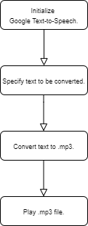

1. Flowchart of Gesture-to-Speech Algorithm

### Implementation Overview

The particular Google Cloud API necessary to perform the text-to-speech conversion is the Google Voice API. In Python, the Google Text-to-Speech library (imported as “gtts,” an abbreviation of “Google Text-to-Speech”) provides the functions for text-to-speech conversion. Before speech-to-text conversion is performed, the output of the neural network is saved on a text file. This text file will be read through the Numpy library’s “genfromtxt” function and the result will be passed to the “gTTS” function as an argument. The “genfromtxt” function requires the user to specify a data type so that the contents read from the desired file will be in the user’s desired form. Meanwhile, the “gTTS” function, imported from the Google Text-to-Speech library, will generate a sound file which contains the finished conversion. This sound file will be played through a function from the Playsound library, which is a Python library that is compatible with Microsoft, Linux, and Apple operating systems. If left unmanaged, every finished conversion will initialize a different sound file. This is a problem, as it can clutter up the user’s storage space. As a solution, the “remove” function from the OS library will be used to delete the output file from the hard drive once most of the program has finished executing.

## Implementation of Task 5

### Implementation Flowchart

The flowchart in Figure 31 describes the basic operation of any speech-to-text program. First, the code will be written to acquire audio. Afterward, this audio will be passed to a speech recognition API for processing. The Speech Recognition library has a function for handling noise, so it will be used to maximize the recognizer’s performance. Any recognizer can be used; there is no “ideal” recognizer and, ultimately, the choice of recognizer is up to the user’s preference. After all, the Speech Recognition library not only simplifies the process of communicating with these recognizers, it also provides a breadth of recognizers to choose from. Like with the gesture-to-text output, the output of the recognizer will be printed to a GUI, so care must be taken to ensure that the correct output is displayed. This is where exceptions come into play. An exception is a fundamental coding concept that involves disrupting the flow of a program. Exceptions are typically used to detect something undesirable. In the case of speech recognition APIs, instances where the recognizer is unable to recognize speech, are undesirable. Ergo, an exception should be written to identify when these instances occur. If the exception is triggered, the user will be prompted to try again. Otherwise, the resulting speech-to-text output will be displayed on the GUI.

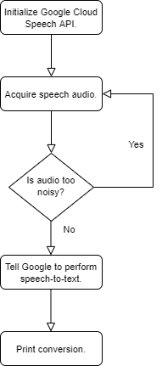

1. Flowchart of Speech-to-Text Algorithm

### Implementation Overview

The Speech Recognition library is a useful Python library for speech-to-text conversion. Developed by Andrew Zhang, its purpose is to provide an easy-to-use interface with different speech recognition APIs. Some of these speech recognition APIs include the Microsoft Bing Speech API, the Google Web Speech API, and the IBM Speech-to-Text API. The Speech Recognition library has implemented functions that allow programmers to easily access speech recognition APIs. For example, the “recognize_google” function is used to establish two-way communications with the Google Web Speech API. Sign AI will be using the Google Web Speech API (and, by extension, the “recognize_google” function from the Speech Recognition library) to perform all of its speech-to-text conversion. For normal operation, the Speech Recognition library has one dependency. When using a microphone peripheral, the PyAudio library will be required to access the received audio.

In addition to its base functionality, the Speech Recognition library also offers other helpful features. One of these features involves dealing with noise in the audio. Noise can degrade the quality of an audio file to varying degrees. Regardless of the severity of the noise or its type, it will undoubtedly affect the accuracy of the speech recognition software. To account for noise in the audio, one can use the “adjust_for_ambient_noise” function in the Speech Recognition library. The “adjust_for_ambient_noise” function increases or decreases the sensitivity of the speech recognition software by manipulating the energy threshold. The energy threshold is used as a cutoff to distinguish speech from noise, where every sound that fails to reach the specified energy threshold will be ignored.

## Implementation of Task 6

### Preliminary Considerations

When developing a graphical user interface (or GUI for short), both form and function go hand-in-hand. In terms of form, a GUI should be easy-to-navigate; in terms of function, it should require as little heavy lifting or accommodation from the user as possible. Firstly, the design of a GUI should not be littered with features. There is such a thing as sensory overload, after all. Having more functions usually translates to having more UI elements. This can end up cluttering the user’s screen and make going through the GUI troublesome. Although a GUI that has countless functions sounds like an ideal to strive for, its layout will take careful planning. Secondly, the GUI should be targeted to fulfill a specific purpose. What is the GUI supposed to allow the user to do? In the case of Sign AI, the purpose of the GUI is to acquire and display gesture information. The GUI will package the neural network and the communication features (speech-to-text and text-to-speech) into one. It also will lay the groundwork for establishing the means of receiving and processing data from the user.

### GUI Design

It was decided that the GUI for Sign AI will be simple and fulfill 3 basic functions: acquiring sensor data from the Myo armband, sending sensor data to the neural network for processing, and acquiring speech data to be converted to text (and vice-versa) by Google APIs. Since the GUI will be written using the Python language, the Tkinter library will be used to develop it. The Tkinter library compiles and adapts the Tk GIU toolkit written in its language to Python. One main benefit of using Tkinter for GUI development is that it is a cross-platform library, meaning that GUIs spawned from it can be run on Microsoft, Linux, and Apple operating systems. It is also equipped with all the traditional UI elements found in most GUIs such as buttons, drop-downs, and checkboxes.

Typically, buttons are used for executing something at the behest of the user. If the user clicks a button, the user wants to run the function that said button performs. I will be using buttons to give the user a choice to perform a gesture (which will be passed in the form of sensor data to the neural network) or to listen to speech from another party. There will be 2 buttons to encompass these functions, and the buttons will be aptly labeled the “Perform ASL” button and “Listen to Others” button, respectively. In addition to the “Perform ASL” button, a “Speak” button will be created to actualize its output in sound form. This also doubles as a way for the user to check the output, ensuring that their desired gesture was translated before performing the text-to-speech and vocalizing said gesture. We will also require a means of display outputs to the user. Thankfully, fields can be implemented to satisfy this purpose. These fields are filled with the appropriate information once the button is pressed and the function accompanying it is finished executing. A rough draft of the proposed GUI is outlined in the figure below.

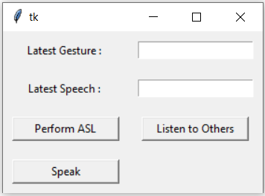

1. Preliminary design of the GUI

### Refining GUI

The previous GUI design was flawed in that it required the user to press the button every time he or she wanted to translate a gesture. This can become tedious if the user wants to perform many gestures successively. Therefore, changes were instituted to accommodate bulk translation. There is a problem with this, however. Without some sort of signal telling the user when to perform the gesture, the sensor will record data when the user is not prepared. To remedy this, a status message field was created to tell the user *when* the GUI was doing *what*. Also, list-boxes were implemented to keep track of all gestures performed, and the speech decoded by Google’s Speech-to-Text API. A timestamp is kept for all GUI outputs, so the user knows when said outputs were produced. Figure 32 illustrates the revised GUI design, with the list-boxes and status message field in place.

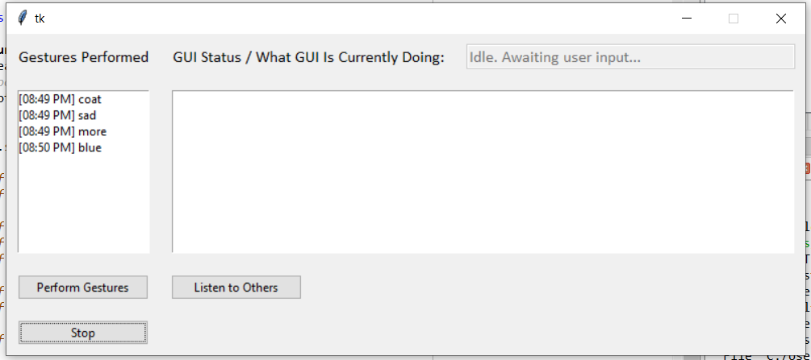

1. Revised GUI design

### Programming the GUI

The Tkinter library has 2 means of allowing the user to layout UI elements and to position them: pack and grid. The grid method will be used here. In the grid method, the window is treated like it is separated by rows and columns. The “grid configure” function is used to specify the row and column in which a UI element should be placed. If only the row is specified for a UI element, it will take the first available column in that row. For the sake of code organization, object-oriented programming will be used, which means that a class will be created for the GUI. Every class contains a set of methods, which, in the realm of procedural programming, are the functions that it can perform. It has the special “self” parameter, which allows the overall class to be able to access attributes and methods associated with it. This is unlike procedural programming, where everything contained within a function is local and cannot be accessed outside of the said function.

In Python, making GUIs that call long-running processes through button clicks is not straightforward. This is because Tkinter GUIs are not capable of performing asynchronous tasks without outside help. The Tkinter GUI updates itself as well as executes all other user-defined functions or methods in a single thread. The GUI updating itself is last in the pecking order. To make matters worse, if the GUI does not receive the request to update itself within a short time, it will become unresponsive, which will prompt the operating system to shut it down and diagnose it. If you call a long-running process, the program will inevitably branch from the main loop where the GUI updates itself to the long-running process that was just called. If your program branches from the main loop for too long, the GUI glitches out and turns unresponsive to any stimulus. Although there is a chance for the GUI to become responsive again, letting it become unresponsive in the first place is a sign of bad programming.

To allow my GUI to call a long-running process, I decided to use the multiprocessing library in conjunction with implementing a queue where outputs from long-running processes are polled periodically. It should be noted that the queue is a FIFO (first-in, first-out) structure, the opposite of a stack, which is a LIFO (last in, first out) structure. This means that its contents are fetched in the order they were put in. The multiprocessing library will allow my GUI to bypass Python’s global interpreter lock (GIL) and spawn concurrent processes. Recall that the GIL prevents Python from running multiple threads at once. This is effectively dealt with by spawning sub-processes instead. The multiprocessing library is compatible with Windows and Unix systems, but not Apple systems. The queue (which was imported from the Queue library) is made to be a global variable, meaning that it can be accessed and modified by anything in the code space. Methods were written that allow the GUI to put content and retrieve content from the queue. On button click, the multiprocessing library spawns the desired subprocesses. At 10 millisecond intervals, the program checks whether or not the subprocess is still executing. If the subprocess is indeed still executing, the program is instructed to wait until it finishes execution, allowing the GUI to update UI elements without interruption. Once executed, the output of the subprocess is appended to the queue, where it can be fetched. The reason behind the success of this implementation lies in the fact that the GUI is not running the subprocess inside the loop where it is supposed to update UI elements. In this implementation, the only thing that the GUI is responsible for is fetching the output of the subprocesses from the queue. This fetching process takes but a fraction of a second, which means it does not disturb the flow of the main loop and will not render the GUI unresponsive.

### Testing the GUI in Real-Time

Once the neural network was trained and the GUI put together, real-time translation work was done to gauge the accuracy of the final product. Table 2 splits up all 100 gestures in 3 categories: first 3 attempts, between 5 to 10 attempts, and beyond 10 attempts. Each category describes the number of attempts that were needed to get a correct translation of a gesture. Gestures belonging in the first category were gestures which the neural network was easily able to recognize. Most if not all gestures in the said category were recognized on the first attempt. Meanwhile, gestures belonging in the second category were gestures which the neural network was capable of recognizing, but with a little more difficulty. Detection of these gestures relied on performing the versions of the gestures that the neural network was trained with. Putting personal variations on these gestures – no matter how slight – can cause occasional mispredictions. On the other hand, gestures belonging in the final category were gestures which the neural network consistently mispredicted. Many of these gestures overlap with other gestures in terms of the types of motion performed, which make them tricky for the neural network to recognize.

1. **Evaluating Performance via Measuring Number of Translation Attempts**

|  |  |  |
| --- | --- | --- |
| **First 3 Attempts** | **Between 5 to 10 Attempts** | **Beyond 10 Attempts** |
| Sister, brother, aunt, uncle, separate, day, hot, cold, hamburger, egg, fork, hungry, socks, shoes, coat, hurt, bathroom, sleep, sad, sorry, bad, excuse, help, who, where, big, tall, full, more, blue, yellow, red, brown, orange, cost, bird, horse, sheep, pig, bug | Gold, silver, drink, spoon, angry, single, home, work, school, store, church, come, go, in, out, with, night, week, year, today, finish, hotdog, apple, cheese, cup, cereal, water, candy, cookie, cat | Mom, dad, marriage, grandma, grandpa, baby, pants, underwear, brush, nice, cry, like, good, love, please, thank you, what, when, why, how, stop, green, dollars, dog, cow, children, future, here, milk |

The accuracy of Sign AI in determining a gesture on its first try was also tested. The test was done a total of 5 times, with each gesture performed just once. The average number of gestures that Sign AI could guess correctly was 49. The results for each trial are recorded in Table 4. As expected, while performing the test, most of the gestures that were guessed correctly on the first try were the gestures that belonged in the first category of Table 3. In most trials, these gestures were guessed correctly by the neural network. On the other hand, there were times when the neural network guessed gestures in categories 2 and 3 (albeit, with lesser frequency, especially for gestures in category 3). These “lucky” guesses can explain why the range of correctly-guessed gestures between all trials is moderately high.

1. **Evaluating the Accuracy of Gesture Detection in First Attempt**

|  |  |
| --- | --- |
| Trial Number | Correctly-Guessed Gestures (Out of 100) |
| 1 | 46 |
| 2 | 55 |
| 3 | 44 |
| 4 | 53 |
| 5 | 48 |
| Average | 49 |

There are a couple of reasons why the real-time performance of the translator pales in comparison to the performance projected in Keras. One potential reason lies in the inevitable variations in EMG readings. In theory, EMG readings can be used to measure the activation of muscle from an electrical domain. However, the reality is that, despite the normalization done by the Myo armband on the raw EMG signals, certain factors can, without fail, throw off one’s EMG readings, especially non-invasive EMG like surface EMG. It was discussed in a paper by Raez, Hussain, and Mohd-Yasin that a person’s physical makeup can very well influence their electrical state: “Anatomical, biochemical and physiological factors take place due to the number of muscle fibers per unit, depth and location of active fibers, and amount of tissue. These factors are called internal noise and directly affect EMG signal quality. The amount of the tissue between contracting muscles and electrodes, along with their thickness, affects the amplitude of the EMG signal” [19]. Also, muscular diseases can lead to abnormal surface as well intra-muscular EMG readings, as can slight changes in skin conductance (which can be caused even by changes in one’s mood) [20], [21]. The point is that there is no surefire catch-all when it comes to EMG. Such is likely the reason why there is a performance gap between the performance projected by Keras and real-time performance.

Statistical analysis was done on the distributions of EMG readings measured when certain gestures (particularly, the “marriage” gesture) were performed. Keep in mind that the “marriage” gesture is a gesture that the neural network has immense trouble classifying. All 100 training samples of the “marriage” gesture were recorded in a 20-bin histogram in an attempt to find an average distribution. The resulting histogram can be viewed in Figure 27. For comparison, Figure 32 depicts one random sample of the “marriage” gesture in the training dataset. The similarities between Figures 32 and 33 are apparent, as the distributions for both histograms are concentrated in the bins directly adjacent to 0. This distribution makes sense as there is not much muscle contraction in the “marriage” gesture (which means EMG readings *should* be on the low side). The hands are in a mostly relaxed position until it is time to squeeze one hand around the other. In contrast, Figures 34 and 35 depict distributions that, despite being EMG readings from the same gesture, are unlike Figures 32 and 33. The disparities between the distribution pairs can mean several things: that the specimen’s emotional state varied from the training dataset, or that the force with which the gestures were performed was different. For either case, the bottom line is that skin conductance is affected, which in turn affects surface EMG readings.

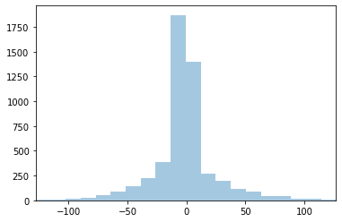

1. EMG readings of all samples of the “marriage” gesture (train)

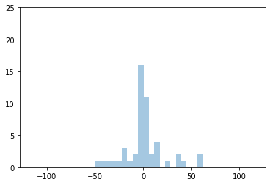

1. A random EMG sample of the “marriage” gesture (train; right prediction)

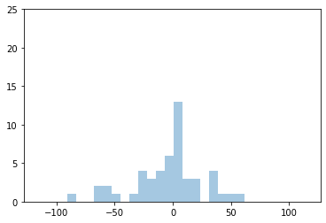

1. “Marriage” performed with increased force (wrong prediction)

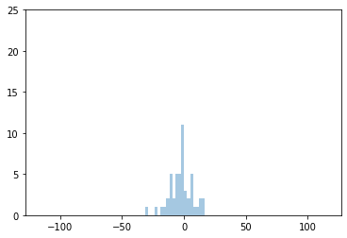

1. “Marriage” performed after exercise (wrong prediction)

Based on the overall distribution depicted in Figure 32, there is a “common case” sample that the neural network was trained with. This “common case” sample is akin to the distribution in Figure 33. Looking at the overall distribution, it is apparent that most data points in the sample were clustered within a specific region of bins. As the distribution moves away from these bins, the number of instances get progressively smaller. This could mean that outliers in EMG were not accounted for very much in the sample size, which is true as most if not all training samples for each gesture were taken at one point in time where the specimen’s general condition was the same throughout. Figure 34 was collected from a gesture performed with more force (which is reflected in the wider distribution), and it was predicted incorrectly by the neural network. Meanwhile, Figure 35 was collected from a gesture performed after exercise, and, again, it was predicted incorrectly by the neural network. Although the circumstances behind when each gesture was performed were different, the baseline was that – in each circumstance – skin conductance was either increased or decreased. In the case of Figure 34, skin conductance increased due to an increase in the action potential. The opposite is true for Figure 35, where exercise-induced sweat prevented sensors from making contact with the skin, thus dampening EMG readings. This is also supported by a study that found that even as little as 0.02 mm of sweat can cause surface EMG readings to clip [22]. In short, there is some evidence to the fact that variations in surface EMG – along with the lack of diversity in the sample space – could have affected the neural network’s performance.

1. Conclusion

The goal of Sign AI was to design a translation tool for American Sign Language (ASL). I hoped to use a neural network built through a combination of Tensorflow and the Keras API to recognize different ASL gestures. It was an undertaking that required me to dive into the realm of AI and deep learning. Many things were learned throughout the design process, one of which is the inner workings of the neural network as well as proposed techniques that have been used to bolster its performance. For example, I learned that the reason behind training a neural network is to tune its weights, which were parameters that help to map the inputs to their correct output. Also, I learned of regularization methods that can prevent the neural network from “overfitting” (or, in layman’s terms, “memorizing”) the training data, the data that it extracts “features” from – features it can use to differentiate one input from another input.

Alongside learning about the neural network, Tensorflow, and Keras, I also learned about the Tkinter library, a Python library that is often used for GUI development. Specifically, I learned that long-running processes or processes needing to be run concurrently cannot be handled by a Tkinter GUI alone. This is due to Python’s GIL as well as Tkinter single-threaded event structure. If the GUI is not updated at a constant rate, it will undoubtedly crash. This problem forced me to think outside the box and implement a queue. Although the GUI was still required to retrieve outputs from long-running processes, it will not be responsible for executing them. Rather, the job of the GUI was simply to get the outputs from the queue through a simple process that will not interrupt its regular update of visual elements.

Although the final product was not as accurate as I expected, and despite the limited dataset due to the pandemic (which made it difficult to physically interact with others), it was still able to translate 40 of the 100 gestures (see category 1 of Table 3) consistently. As for the other gestures, I have noted accuracy fluctuations with them. Gestures in category 2 were still recognizable to the neural network, though it was apparent that there was more difficulty in squeezing out correct guesses. It seemed that even small to moderate variations from the training data tended to make the neural network mispredict. This was doubly true for the gestures in category 3; these gestures were demonstrably harder for the neural network to recognize. I attributed the mispredictions of the neural network to the flaws of surface EMG.

For the future, there are certain ideas that can improve the current state of the project. In the former half of the paper, I lambasted the idea of using image-based training data for the neural network. However, this idea does have its merits. To anyone who is considering continuing the work that has been done thus far, I have one suggestion: the implementation of a multi-input neural network that processes sequences of image data as well as data from the Myo armband. Also, I would suggest using a second Myo armband so that both arms are taken into account. Moderate success has been achieved in using image-based data for gesture classification. However, I believe that more success can be achieved if it is combined with information that can be gleaned from the Myo armband.

Acknowledgments

I would like to thank Dr. Jason Brownlee for his tutorials on machine learning and deep learning algorithms. Your tutorials have helped me in my efforts to understand the inner workings of the neural network.

Appendix

1. Device Specifications
2. Device Specifications of Myo Armband
3. **Myo Armband Specifications [6]**

|  |  |
| --- | --- |
| Sensors | Medical grade stainless steel EMG sensors  Highly sensitive nine-axis IMU containing three-axis gyroscope, three-axis accelerometer, three-axis magnetometer |
| LEDs | Dual indicator LEDs |
| Processor | ARM Cortex M4 processor |
| Charging | Micro-USB |
| Battery | Built-in rechargeable lithium-ion battery |
| Arm Size | Expandable between 7.5-13 inches (19-34 centimeters) forearm circumference |
| Weight | 93 grams |
| Thickness | 0.45 inches (1.14 centimeters) |

1. Source Code
2. Source Code for GUI

"""

Finalized GUI for Sign AI.

"""

import tkinter as tk

import tkinter.ttk as ttk

from tkinter import scrolledtext

from multiprocessing import Process, Queue

from queue import Empty

from myo.utils import TimeInterval

import myo

import collections

import numpy as np

import time

import subprocess

from gtts import gTTS

from playsound import playsound

import os

import speech_recognition as STT

my_queue = Queue()

speech_queue = Queue()

class Listener(myo.DeviceListener):

def __init__(self):

self.interval = TimeInterval(None, 0.05)

self.orientation = None

self.pose = myo.Pose.rest # unused

self.emg_enabled = True

self.locked = False

self.rssi = None

self.emg = None

def output(self):

if not self.interval.check_and_reset():

return

sample_count = int(np.loadtxt('sample_count.txt'))

sample_limit = 50

# files containing EMG and orientation data.

quat_w = open("quaternion_w" + ".txt", "a+")

quat_i = open("quaternion_i" + ".txt", "a+")

quat_j = open("quaternion_j" + ".txt", "a+")

quat_k = open("quaternion_k" + ".txt", "a+")

emgPod_1 = open("emgPod1" + ".txt", "a+")

emgPod_2 = open("emgPod2" + ".txt", "a+")

emgPod_3 = open("emgPod3" + ".txt", "a+")

emgPod_4 = open("emgPod4" + ".txt", "a+")

emgPod_5 = open("emgPod5" + ".txt", "a+")

emgPod_6 = open("emgPod6" + ".txt", "a+")

emgPod_7 = open("emgPod7" + ".txt", "a+")

emgPod_8 = open("emgPod8" + ".txt", "a+")

# temp variables for EMG and orientation data.

quaternions_read = collections.deque(maxlen=4)

instances_quat = 4

emg_read = collections.deque(maxlen=8)

instances_emg = 8

if sample_count != sample_limit:

if self.orientation and self.emg:

# get orientation data.

for element in self.orientation:

quaternions_read.append(element)

instances_quat = instances_quat - 1

if instances_quat == 0:

quat_w.write(str(quaternions_read[0]) + ' ')

quat_i.write(str(quaternions_read[1]) + ' ')

quat_j.write(str(quaternions_read[2]) + ' ')

quat_k.write(str(quaternions_read[3]) + ' ')

# get EMG data.

for element in self.emg:

emg_read.append(element)

instances_emg = instances_emg - 1

if instances_emg == 0:

emgPod_1.write(str(emg_read[0]) + ' ')

emgPod_2.write(str(emg_read[1]) + ' ')

emgPod_3.write(str(emg_read[2]) + ' ')

emgPod_4.write(str(emg_read[3]) + ' ')

emgPod_5.write(str(emg_read[4]) + ' ')

emgPod_6.write(str(emg_read[5]) + ' ')

emgPod_7.write(str(emg_read[6]) + ' ')

emgPod_8.write(str(emg_read[7]) + ' ')

# updates sample count.

sample_count = sample_count + 1

np.savetxt('sample_count.txt', [sample_count])

else:

pass

# close files with orientation data once they will no longer be accessed.

quat_w.close()

quat_i.close()

quat_j.close()

quat_k.close()

# close files with EMG data once they will no longer be accessed.

emgPod_1.close()

emgPod_2.close()

emgPod_3.close()

emgPod_4.close()

emgPod_5.close()

emgPod_6.close()

emgPod_7.close()

emgPod_8.close()

def on_connected(self, event):

event.device.request_rssi()

event.device.stream_emg(True)

def on_rssi(self, event):

self.rssi = event.rssi

self.output()

def on_pose(self, event):

self.pose = event.pose

self.output()

def on_orientation(self, event):

self.orientation = event.orientation

self.output()

def on_emg(self, event):

self.emg = event.emg

self.output()

def on_unlocked(self, event):

self.locked = False

self.output()

def on_locked(self, event):

self.locked = True

self.output()

class SignAI_GUI:

def __init__(self, root):

# the master window.

self.root = root

# make GUI not resizable for formatting's sake.

self.root.resizable(height=False, width=False)

# empties data files.

reset()

# dictates when gesture translation stops.

self.stopped_process = False

# status-related flavor text.

self.guiStatus = ["Idle. Awaiting user input...",

"Acquiring sensor data...",

"Interfacing with neural network...",

"Performing text-to-speech conversion...",

"Performing speech-to-text conversion..."]

self.currentStatus = tk.StringVar()

self.currentStatus.set(self.guiStatus[0])

# UI elements.

self.gestureListLabel = ttk.Label(master=self.root, text="Gestures Performed")

self.gestureListLabel.grid(row=0, sticky="w")

self.gestureListLabel.config(font=("Calibri", 12))

self.progressStatus = ttk.Label(master=self.root, text="GUI Status / What GUI Is Currently Doing:")

self.progressStatus.config(font=("Calibri", 12))

self.progressStatus.grid(row=0, column=1, sticky="e")

self.statusChecker = ttk.Entry(master=self.root, width=40, textvariable=self.currentStatus, state=tk.DISABLED)

self.statusChecker.config(font=("Calibri", 12))

self.statusChecker.grid(row=0, column=2)

self.gestureList = tk.Listbox(master=self.root)

self.gestureList.grid(row=1, sticky="nsew")

self.speechBox = tk.Listbox(master=self.root)

self.speechBox.grid(row=1, column=1, columnspan=3, sticky="nsew")

"""

self.speechBox = scrolledtext.ScrolledText(master=self.root, state=tk.DISABLED)

self.speechBox.grid(row=1, column=1, columnspan=3, sticky="nsew")

"""

self.speakButton = ttk.Button(master=self.root, text="Perform Gestures", command=self.onSpeakBuffer, width=20)

self.speakButton.grid(row=2)

self.listenButton = ttk.Button(master=self.root, text="Listen to Others", command=self.onSTT, width=20)

self.listenButton.grid(row=2, column=1, sticky="w")

self.stopSpeakButton = ttk.Button(self.root, text="Stop", command=self.stop_all_processes, width=20)

self.stopSpeakButton.grid(row=3)

# initiating processes.

self.speak_process = Process(target=onGetGesture, args=())

self.STT_process = Process(target=perform_STT, args=(speech_queue,))

def onSTT(self):

self.stopped_process = True

if (self.speak_process.is_alive()):

self.speak_process.terminate()

reset()

self.listenButton.config(state=tk.DISABLED)

self.currentStatus.set(self.guiStatus[4])

self.root.update_idletasks()

self.STT_process = Process(target=perform_STT, args=(speech_queue,))

self.STT_process.start()

self.root.after(10, self.onWaitSTT)

def onWaitSTT(self):

if (self.STT_process.is_alive()):

self.root.after(10, self.onWaitSTT)

return

else:

self.t = time.localtime()

self.current_time = time.strftime("%I:%M %p", self.t)

self.speechBox.insert(tk.END, '[' + self.current_time + ']' + ' ' + speech_queue.get(0))

self.listenButton.config(state=tk.NORMAL)

self.currentStatus.set(self.guiStatus[0])

self.root.update_idletasks()

def onSpeakBuffer(self):

if self.stopped_process == True:

self.stopped_process = False

else:

pass

self.onSpeak()

def onSpeak(self):

if self.stopped_process == False:

self.currentStatus.set(self.guiStatus[1])

self.speakButton.config(state=tk.DISABLED)

self.speak_process = Process(target=onGetGesture, args=())

self.speak_process.start()

self.root.after(10, self.onPrintGesture)

else:

if self.speak_process.is_alive:

self.speak_process.terminate()

else:

pass

def onPrintGesture(self):

if (self.speak_process.is_alive()):

#self.root.update_idletasks()

self.root.after(10, self.onPrintGesture)

return

else:

if self.stopped_process == False:

self.currentStatus.set(self.guiStatus[2])

self.root.update_idletasks()

self.translationProcess = Process(target=onContactNN, args=(my_queue,))

self.translationProcess.start()

self.translationProcess.join()

self.t = time.localtime()

self.current_time = time.strftime("%I:%M %p", self.t)

self.gestureList.insert(tk.END, '[' + self.current_time + ']' + ' ' + str(my_queue.get(0)))

self.currentStatus.set(self.guiStatus[3])

self.root.update_idletasks()

self.TTSprocess = Process(target=perform_TTS, args=())

self.TTSprocess.start()

self.TTSprocess.join()

self.onSpeak()

else:

if self.speak_process.is_alive:

self.speak_process.terminate()

else:

pass

def stop_all_processes(self):

self.stopped_process = True

if (self.speak_process.is_alive()):

self.speak_process.terminate()

reset()

self.currentStatus.set(self.guiStatus[0])

self.speakButton.config(state=tk.NORMAL)

def start_hub():

myo.init('myo-sdk-win-0.9.0/bin/myo64.dll')

hub = myo.Hub()

listener = Listener()

max_time_allowed = 3.5 # in seconds.

start = time.time()

while hub.run(listener.on_event, 500):

if time.time() - start > max_time_allowed:

hub.stop()

break

def reset():

file_directory = ["emgPod1.txt", "emgPod2.txt", "emgPod3.txt",

"emgPod4.txt", "emgPod5.txt", "emgPod6.txt",

"emgPod7.txt", "emgPod8.txt",

"quaternion_w.txt", "quaternion_i.txt",

"quaternion_j.txt", "quaternion_k.txt"]

# reset data files after use.

for files in file_directory:

doc = open(files, "w")

doc.write('')

doc.close()

# reset sample count to 0.

np.savetxt("sample_count.txt", [int(0)])

def onGetGesture():

start_hub() # begin acquiring sensor data.

def onContactNN(my_queue):

subprocess.call("contact_NN.py", shell=True)

output = np.genfromtxt("output_gesture.txt", dtype="str")

my_queue.put(output)

reset() # dump out data in sensor files.

def perform_STT(speech_queue):

output = speech2text()

speech_queue.put(output)

def speech2text():

# initialize gTTS.

converter = STT.Recognizer()

with STT.Microphone() as sound:

# filter out noise when audio is received.

converter.adjust_for_ambient_noise(sound)

# acquire audio.

output = converter.listen(sound)

# store converted output in 'speech' variable.

try:

speech = converter.recognize_google(output)

except:

speech = 'Try again'

return speech

def perform_TTS():

sound_file = "output_TTS.mp3"

gesture = str(np.genfromtxt("output_gesture.txt", dtype="str"))

# passes text to Google Voice.

tts = gTTS(text=gesture, lang="en")

# saves text as .mp3.

tts.save(sound_file)

# play .wav file via playsound.

playsound(sound_file)

# deletes sound file after use.

os.remove(sound_file)

def main():

root = tk.Tk()

app = SignAI_GUI(root)

for child in root.winfo_children():

child.grid_configure(padx=10, pady=10)

root.mainloop()

if __name__ == '__main__':

main()

1. Source Code for Data Logger

"""

Record orientation and EMG data from Myo and log in a text file.

"""

from __future__ import print_function

from myo.utils import TimeInterval

import myo

import collections

class Listener(myo.DeviceListener):

def __init__(self):

self.interval = TimeInterval(None, 0.05)

self.orientation = None

self.pose = myo.Pose.rest # unused

self.emg_enabled = True

self.locked = False

self.rssi = None

self.emg = None

def output(self):

if not self.interval.check_and_reset():

return

sample_parameters = collections.deque(maxlen=2)

sample_limit = 50

with open("sample_parameters.txt") as file_sampleParam:

for line in file_sampleParam:

for num in line.split(','):

sample_parameters.append(int(num))

sample_count = sample_parameters[0]

sample_number = sample_parameters[1]

if sample_count == sample_limit:

contVar = int(input("Do you want to continue? "))

if contVar == 1:

sample_number = sample_number + 1

sample_count = 0

else:

pass

else:

quat_w = open("quaternion_w" + "_" + str(sample_number) + ".txt", "a+")

quat_i = open("quaternion_i" + "_" + str(sample_number) + ".txt", "a+")

quat_j = open("quaternion_j" + "_" + str(sample_number) + ".txt", "a+")

quat_k = open("quaternion_k" + "_" + str(sample_number) + ".txt", "a+")

emgPod_1 = open("emgPod1" + "_" + str(sample_number) + ".txt", "a+")

emgPod_2 = open("emgPod2" + "_" + str(sample_number) + ".txt", "a+")

emgPod_3 = open("emgPod3" + "_" + str(sample_number) + ".txt", "a+")

emgPod_4 = open("emgPod4" + "_" + str(sample_number) + ".txt", "a+")

emgPod_5 = open("emgPod5" + "_" + str(sample_number) + ".txt", "a+")

emgPod_6 = open("emgPod6" + "_" + str(sample_number) + ".txt", "a+")

emgPod_7 = open("emgPod7" + "_" + str(sample_number) + ".txt", "a+")

emgPod_8 = open("emgPod8" + "_" + str(sample_number) + ".txt", "a+")

quaternions_read = collections.deque(maxlen=4)

instances_quat = 4

emg_read = collections.deque(maxlen=8)

instances_emg = 8

if self.orientation and self.emg:

for element in self.orientation:

quaternions_read.append(element)

instances_quat = instances_quat - 1

if instances_quat == 0:

quat_w.write(str(quaternions_read[0]) + ' ')

quat_i.write(str(quaternions_read[1]) + ' ')

quat_j.write(str(quaternions_read[2]) + ' ')

quat_k.write(str(quaternions_read[3]) + ' ')

for element in self.emg:

emg_read.append(element)

instances_emg = instances_emg - 1

if instances_emg == 0:

emgPod_1.write(str(emg_read[0]) + ' ')

emgPod_2.write(str(emg_read[1]) + ' ')

emgPod_3.write(str(emg_read[2]) + ' ')

emgPod_4.write(str(emg_read[3]) + ' ')

emgPod_5.write(str(emg_read[4]) + ' ')

emgPod_6.write(str(emg_read[5]) + ' ')

emgPod_7.write(str(emg_read[6]) + ' ')

emgPod_8.write(str(emg_read[7]) + ' ')

sample_count = sample_count + 1

#print(quaternions_read)

#print(emg_read)

quat_w.close()

quat_i.close()

quat_j.close()

quat_k.close()

emgPod_1.close()

emgPod_2.close()

emgPod_3.close()

emgPod_4.close()

emgPod_5.close()

emgPod_6.close()

emgPod_7.close()

emgPod_8.close()

file_sampleParam = open("sample_parameters.txt", "w")

file_sampleParam.write(str(sample_count) + ',' + str(sample_number))

file_sampleParam.close()

def on_connected(self, event):

event.device.request_rssi()

event.device.stream_emg(True)

def on_rssi(self, event):

self.rssi = event.rssi

self.output()

def on_pose(self, event):

self.pose = event.pose

self.output()

def on_orientation(self, event):

self.orientation = event.orientation

self.output()

def on_emg(self, event):

self.emg = event.emg

self.output()

def on_unlocked(self, event):

self.locked = False

self.output()

def on_locked(self, event):

self.locked = True

self.output()

if __name__ == '__main__':

myo.init('myo-sdk-win-0.9.0/bin/myo64.dll')

hub = myo.Hub()

listener = Listener()

while hub.run(listener.on_event, 500):

pass

1. Source Code for Speech-to-Text Module

import speech_recognition as STT

def speech2text():

# initialize gTTS.

converter = STT.Recognizer()

with STT.Microphone() as sound:

# filter out noise when audio is received.

converter.adjust_for_ambient_noise(sound)

# acquire audio.

output = converter.listen(sound)

# store converted output in 'speech' variable.

try:

speech = converter.recognize_google(output)

except:

speech = 'Try again'

return speech

1. Source Code for Text-to-Speech Module

from gtts import gTTS

from playsound import playsound

import os

import numpy as np

def getTTSoutput():

gesture = str(np.genfromtxt("output_gesture.txt", dtype="str"))

sound_file = "output_TTS.mp3"

# passes text to Google Voice.

tts = gTTS(text=gesture, lang="en")

# saves text as .mp3.

tts.save(sound_file)

# play .wav file via playsound.

playsound(sound_file)

# deletes sound file after use.

os.remove(sound_file)

getTTSoutput()

1. Source Code for Interfacing with Neural Network

"""

Interface with neural network for gesture recognition.

"""

import numpy as np

import os

from keras.models import load_model

def contact_neuralNet():

# retrieve all data as arrays.

emgPod_1 = np.loadtxt("emgPod1" + ".txt")

emgPod_2 = np.loadtxt("emgPod2" + ".txt")

emgPod_3 = np.loadtxt("emgPod3" + ".txt")

emgPod_4 = np.loadtxt("emgPod4" + ".txt")

emgPod_5 = np.loadtxt("emgPod5" + ".txt")

emgPod_6 = np.loadtxt("emgPod6" + ".txt")

emgPod_7 = np.loadtxt("emgPod7" + ".txt")

emgPod_8 = np.loadtxt("emgPod8" + ".txt")

quat_w = np.loadtxt("quaternion_w" + ".txt")

quat_i = np.loadtxt("quaternion_i" + ".txt")

quat_j = np.loadtxt("quaternion_j" + ".txt")

quat_k = np.loadtxt("quaternion_k" + ".txt")

# stack data element-wise.

input_data = np.dstack((emgPod_1, emgPod_2, emgPod_3,

emgPod_4, emgPod_5, emgPod_6,

emgPod_7, emgPod_8, quat_i,

quat_j, quat_k, quat_w))

# reshape for use in NN.

input_data = np.array(input_data).reshape((1, 50, 12))

# retrieve labels.

directory = 'gesturedat'

catalog = []

for folders in os.listdir(directory):

catalog.append(folders)

"""

model = Sequential()

model.add(LSTM(128, return_sequences=True, input_shape=(50,12)))

model.add(LSTM(128))

model.add(BatchNormalization())

model.add(Dense(100, activation='softmax'))

model.load_weights("finalized_weights.hdf5")

model.compile(loss='sparse_categorical_crossentropy', optimizer="nadam", metrics=['accuracy'])

"""

# load model using appropriate weights.

loaded_model = load_model('final_model-v2.h5')

loaded_model.load_weights('finalized_weights.hdf5')

# interface with model.

raw_prediction = loaded_model.predict_classes(input_data)

output = catalog[raw_prediction[0]]

np.savetxt("output_gesture.txt", [output], fmt="%s")

contact_neuralNet()

References

[1] R. E. Mitchell, “How many deaf people are there in the United States? Estimates from the Survey of Income and Program Participation.,” *J. Deaf Stud. Deaf Educ.*, vol. 11, no. 1, pp. 112–119, 2006, doi: 10.1093/deafed/enj004.

[2] National Institutes of Health, “Quick Statistics About Hearing,” 2016. https://www.nidcd.nih.gov/health/statistics/quick-statistics-hearing.

[3] C. Lou Garberoglio, S. Cawthon, and M. Bond, “Deaf People and Employment in the United States,” *Washington, DC US Dep. Educ. Off. Spec. Educ. Programs, Natl. Deaf Cent. Postsecond. Outcomes*, 2016.

[4] F. G. Bowe, B. T. McMahon, T. Chang, and I. Louvi, “Workplace discrimination, deafness and hearing impairment: The national EEOC ADA research project,” *Work*, vol. 25, no. 1, pp. 19–25, 2005.

[5] B. Stern, “Inside Myo,” 2016. https://learn.adafruit.com/myo-armband-teardown.

[6] S. Pizzolato, L. Tagliapietra, M. Cognolato, M. Reggiani, H. Müller, and M. Atzori, “Comparison of six electromyography acquisition setups on hand movement classification tasks,” *PLoS One*, vol. 12, no. 10, p. e0186132, 2017.

[7] V. Bheda and D. Radpour, “Using deep convolutional networks for gesture recognition in American sign language,” *arXiv Prepr. arXiv1710.06836*, 2017.

[8] W. Vicars, “First 100 Signs.” https://www.lifeprint.com/asl101/pages-layout/concepts.htm.

[9] C. Mythili and V. Kavitha, “Efficient technique for color image noise reduction,” *Res. Bull. Jordan, ACM*, vol. 1, no. 11, pp. 41–44, 2011.

[10] T. Freeman, “What is Imaging Radar?,” [Online]. Available: https://airsar.jpl.nasa.gov/documents/.

[11] J. Sutton, “Algorithmia and BERT Language Modeling,” 2020, [Online]. Available: https://algorithmia.com/blog/algorithmia-and-bert-language-modeling.

[12] Colah, “Understanding LSTM Networks,” 2015. https://colah.github.io/posts/2015-08-Understanding-LSTMs/.

[13] M. Hermans and B. Schrauwen, “Training and Analysing Deep Recurrent Neural Networks,” in *Advances in Neural Information Processing Systems 26*, C. J. C. Burges, L. Bottou, M. Welling, Z. Ghahramani, and K. Q. Weinberger, Eds. Curran Associates, Inc., 2013, pp. 190–198.

[14] N. Srivastava, G. Hinton, A. Krizhevsky, I. Sutskever, and R. Salakhutdinov, “Dropout: a simple way to prevent neural networks from overfitting,” *J. Mach. Learn. Res.*, vol. 15, no. 1, pp. 1929–1958, 2014.

[15] C. Maklin, “Dropout Neural Network Layer In Keras Explained,” 2019. https://towardsdatascience.com/machine-learning-part-20-dropout-keras-layers-explained-8c9f6dc4c9ab.

[16] S. Ioffe and C. Szegedy, “Batch normalization: Accelerating deep network training by reducing internal covariate shift,” *arXiv Prepr. arXiv1502.03167*, 2015.

[17] “Backpropagation Neural Network: Explained With Simple Example.” https://www.guru99.com/backpropogation-neural-network.html.

[18] S. Santurkar, D. Tsipras, A. Ilyas, and A. Madry, “How does batch normalization help optimization?,” in *Advances in Neural Information Processing Systems*, 2018, pp. 2483–2493.

[19] R. H. Chowdhury, M. B. I. Reaz, M. A. B. M. Ali, A. A. A. Bakar, K. Chellappan, and T. G. Chang, “Surface electromyography signal processing and classification techniques,” *Sensors (Basel).*, vol. 13, no. 9, pp. 12431–12466, Sep. 2013, doi: 10.3390/s130912431.

[20] C. Larivière, D. Gagnon, and P. Loisel, “The comparison of trunk muscles EMG activation between subjects with and without chronic low back pain during flexion–extension and lateral bending tasks,” *J. Electromyogr. Kinesiol.*, vol. 10, no. 2, pp. 79–91, 2000.

[21] E. Gatti, E. Calzolari, E. Maggioni, and M. Obrist, “Emotional ratings and skin conductance response to visual, auditory and haptic stimuli,” *Sci. data*, vol. 5, p. 180120, 2018.

[22] M. Abdoli-Eramaki, C. Damecour, J. Christenson, and J. Stevenson, “The effect of perspiration on the sEMG amplitude and power spectrum.,” *J. Electromyogr. Kinesiol. Off. J. Int. Soc. Electrophysiol. Kinesiol.*, vol. 22, no. 6, pp. 908–913, Dec. 2012, doi: 10.1016/j.jelekin.2012.04.009.